Strategic Plan
Accessing Safety in Hennepin County
October 7, 2015
Funding Statement
This project was supported by Grant No. 2013-FW-AX-K004, awarded by the Office on Violence Against Women, U.S. Department of Justice. The opinions, findings, conclusions, and recommendations expressed in this publication/ program/exhibition are those of the author(s) and do not necessarily reflect the views of the Department of Justice, Office on Violence Against Women.

Contents
Introduction 3
Member Organizations 4
Mission 5
Vision 5
Values 6
Needs Assessment Plan Summary 7
Needs Assessment Report Summary 10
Notes about Focus Groups and Interviews 13
Strategic Planning Process 14
Listening Sessions Summary 15
Strategic Plan Initiatives 19
Work Groups 20
Initiative 1: Staff Comfort and Capacity 21
Key Activities 22
Structure 25
Initiative 2: Access and Safety 27
Key Activities 28
Structure 30
Initiative 3: Policies and Procedures 31
Key Activities 32
Structure 34
Initiative 4: Resources 35
Key Activities 36
Structure 38
Initiative 5: Self-Advocates 39
Key Activities 40
Structure 42
Long-Term Initiatives 43
Sustainability 46
Conclusion 48
Appendix 49
Appendix A: Performance Indicator Measurement System Scores 49
Appendix B: Detailed Timeline for Initiatives 52

Introduction
Accessing Safety in Hennepin County is a collaboration between The Arc Greater Twin Cities (The Arc) and the Sexual Violence Center (SVC). The U.S. Department of Justice’s Office on Violence Against Women (OVW) funded this collaboration in 2013. The Arc works with people with intellectual and developmental disabilities (I/DD), and SVC works with people who have been subjected to sexual violence. Together we focus on people with I/DD who are victims/survivors of sexual violence in Hennepin County.
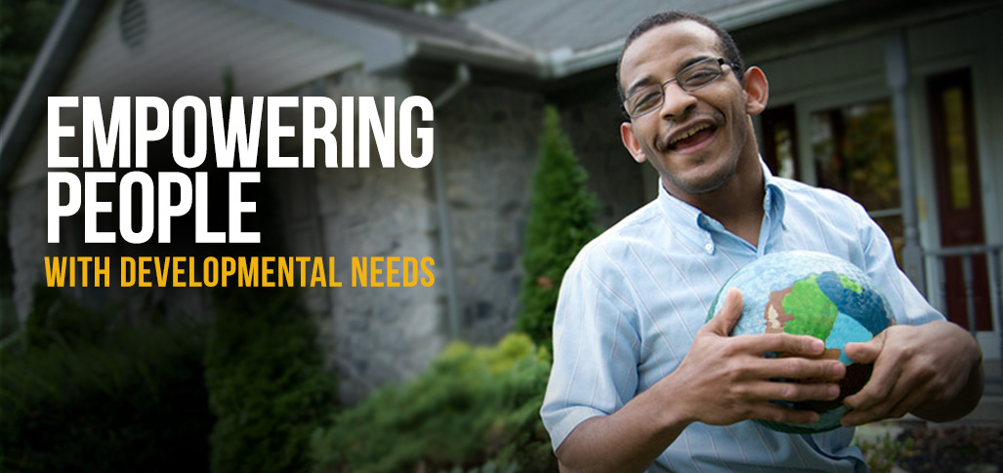
The purpose of the collaboration is to gain a better understanding between The Arc and SVC about our missions, programming and services, staffing, and organizational culture, as well as our limitations. Our work focuses on improving services at both organizations to enable victims/survivors of sexual violence with I/DD to empower themselves with the skills and resources that support healing. We are determined that victims/survivors of sexual violence with I/DD deserve support from people who believe and respect them.

Member Organizations

The Arc Greater Twin Cities
The Arc informs, assists, and advocates for people with intellectual and developmental disabilities such as Down syndrome, autism, fetal alcohol spectrum disorder, cerebral palsy, and other conditions. The Arc works in seven metro counties: Hennepin, Ramsey, Anoka, Carver, Scott, Washington, and Dakota.
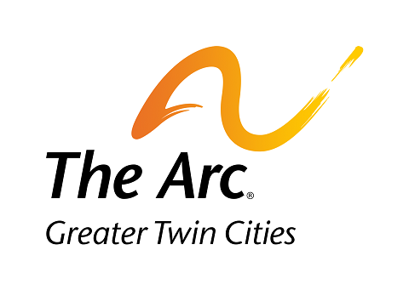

SVC
SVC educates, raises awareness, pushes for systems change, and directly supports victims of sexual violence. SVC serves victims with any disability status who are, at least, 12 years old. SVC works in three metro counties: Hennepin, Carver, and Scott.
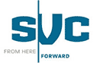

Mission
Our collaboration will improve how we support victims/​survivors with I/DD. We will work together to provide services that respect and empower victims. We will help victims/survivors get the skills and resources they need to heal.

Vision
Our collaboration will create the best possible services for people with I/DD who have been affected by sexual violence. These will be accessible services that focus on the needs of the person. Our services will respect how trauma impacts everyone differently. People we work with will be believed, empowered, and supported. We will work to change the current system that does not treat everyone equally.

Values
The collaboration between The Arc and the SVC is based on shared values. We affirm that everyone has the right to be fully included in the community and feel safe. We share our support for the following rights and values:
- We believe that everyone has the right to autonomy and self-determination. This means that everyone has the right to live, learn, work, play, make decisions, and be involved in relationships in the safest and most accessible setting in any way they choose.
- We believe that everyone has the right to accessibility. We affirm that everyone should have equal physical access as well as equal access to written and spoken information.
- We believe that everyone has the right to safety. This includes freedom from sexual violence. We believe that everyone has the right to define what safety means for them.

Needs Assessment Plan Summary
Our needs assessment had two parts:
1) The Performance Indicator Measurement System, a tool that measures an organization’s capacity to serve victims/survivors with disabilities. The Vera Institute of Justice developed this tool.
2) Focus groups and interviews. We conducted focus groups and interviews with people who have used services at The Arc or SVC. (See page 9 for participants.)
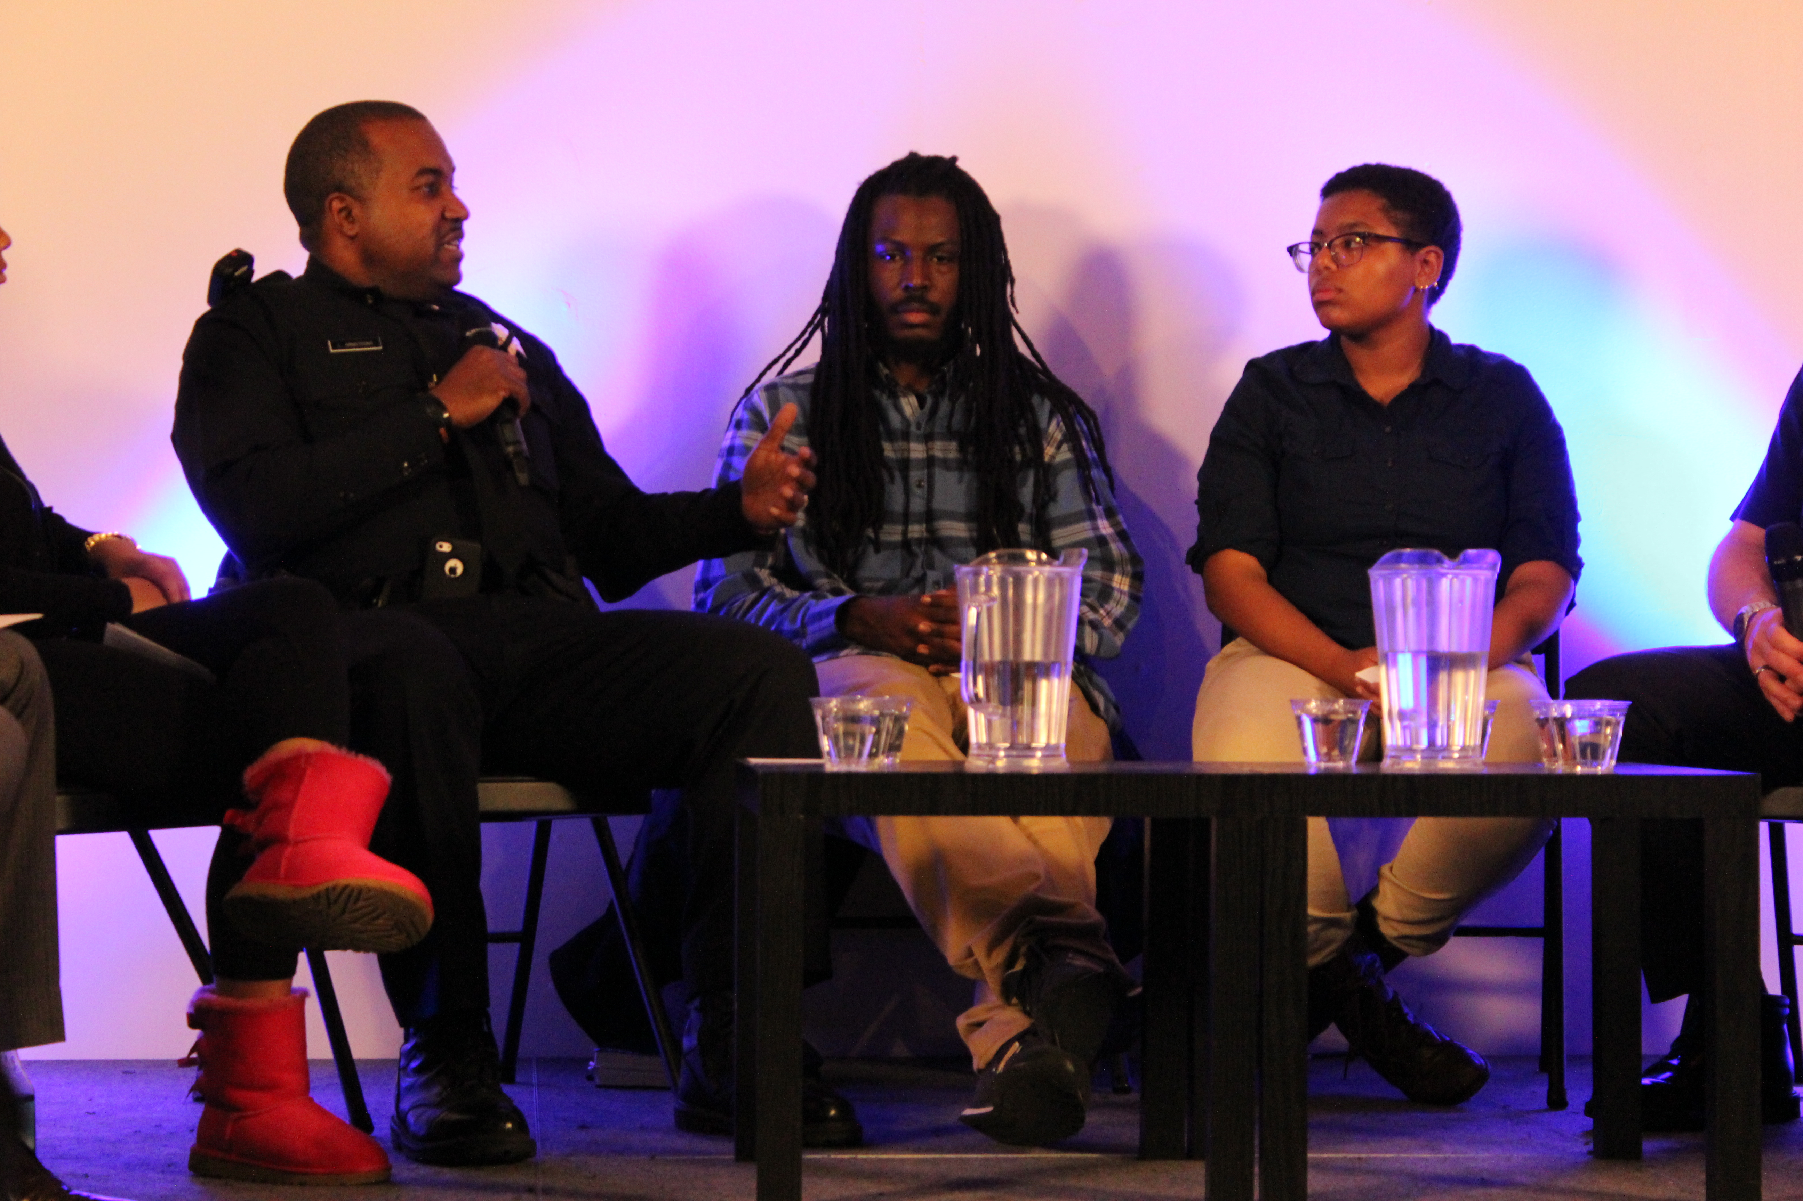
The overarching purpose of the needs assessment was to:
- Provide practical information on services for survivors with intellectual and developmental disabilities and how to improve them;
- Inform our selection of implementation activities; and
- Increase organizational buy-in and support for our collaboration’s work.

Needs Assessment Goals
We took the opportunity presented by our focus groups and interviews to engage with people who have been impacted by the issues of concern to our collaboration. We took to heart the feedback they provided, understanding that their unique perspectives and experiences gave them insight that is not available to collaboration committee members.
Throughout the needs assessment for both SVC and The Arc, we:
- Identified current organizational structures, barriers, and gaps with regard to policies, procedures, and practices at The Arc and SVC. These will address how to respond to, serve, and support victims/survivors with I/DD.
- Determined what supports and limits exist in each organization’s culture to respond to and address staff’s ability to provide a safe, accessible, person-centered and responsive service delivery system for victims/survivors with I/DD.
- Clarified what works and what barriers exist in each organization to ensure accessibility, safety, and responsiveness through the dual lens of sexual violence and I/DD.
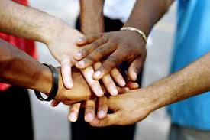
To achieve these goals, we held focus groups and interviews with people who used services at either The Arc or SVC. The following chart shows the groups with whom we spoke:
Focus Group Participants
Participant Groups | Number of focus groups | Number of Interviews | Total number of people who participated
Victims/survivors of sexual violence from SVC | 2 | 3 | 7
Self-Advocates from The Arc | 1 | 1 | 4
Parents and guardians from The Arc | 2 | 3 | 10

Needs Assessment Report Summary
Accessing Safety in Hennepin County found the following themes from what we learned from our focus groups and interviews.

Theme 1
Both organizations need to look inward and outward to address discrimination against people with disabilities.
Needs assessment participants said that self-advocates need to make their own decisions and be in control of their own lives, which is only possible in an environment free of discrimination. All three groups we heard from highlighted the need to provide a variety of communication methods, especially visual materials, for every service we provide. This information should be given freely without participants needing to ask. We need to respect everyone’s unique identities and the communities they come from. We need to learn and teach about sexual violence, domestic violence, discrimination, and how they intersect.
Picture drawn by self-advocate participant
On left: ‘Help, no get in’ (the participant)
On right: ‘We don’t want you over there’ (party goers)

Theme 2
Both organizations need to ensure person-centered services for victims/survivors with I/DD.
Providing person-centered services means asking and using what is important to the person. As one participant who is a self-advocate said, “Hey, we are people too. We are people too. We have feelings.”
Additionally, participants said that for victims/survivors with disabilities, it would be very helpful to have one person helping them through all of the services they get from an organization and have one central place to get information.
Prompt: “When you go somewhere for services and people don’t understand you or your disability, what is that like?”

Theme 3
Both organizations need to create environments that are trauma-informed, inclusive, respectful, strengths-based, welcoming, and ensuring of privacy.
Needs assessment participants said that getting services in a space that is private, home-like, welcoming, and calm is essential. Trauma-informed means that representatives from both organizations will commit to understand what abuse is and how it affects people. This will help us to not hurt those we serve.

Theme 4
Both organizations need to improve outreach efforts to raise visibility about their services.
We need to advertise our services more widely so that we can reach more people. Both organizations need to build a variety of community partnerships to assist victims/survivors with any path they choose. As one participant who is a parent/guardian said, “They (service provider) said he just fell through the cracks. Well, he didn’t fall through the cracks. He’s right here.”

Theme 5
Both organizations need to improve and develop policies that will create sustainable welcoming, safe, inclusive, and accessible services for victims/survivors with I/DD.
We need to develop policies that put the needs and wants of victims/survivors at the center of our work. Flexibility needs to be built into our services. We need to proactively offer services and information before the need arises. As one participant who is a parent/guardian stated, “All of their growth and healing comes from them being able to say things in their own words. Don’t advocate for but advocate with.”
Prompt: “When you go somewhere for services and someone really understands you and your disability, what is that like?” “It’s like hugging chocolate!”

Notes about Focus Groups and Interviews
It is important to note that we did not have as many participants with I/DD as we had originally planned. After talking to the OVW and the Vera Institute of Justice, we decided that The Arc would focus more on parents/guardians. This is because The Arc’s advocacy services are primarily used by parents and guardians.
Second, we did not talk to as many victims/survivors as we had planned. Recruitment for this population was difficult for many reasons, including:
- SVC does not maintain a database of clients served for confidentiality reasons.
- As a safety measure, SVC does not contact clients unless they have already given permission.
Due to the small group sizes, the information we gathered should only be considered a guide. The information does not include perspectives from people of all identities who have been subjected to sexual violence. The information does not take the place of asking every person we serve about their own thoughts and views.
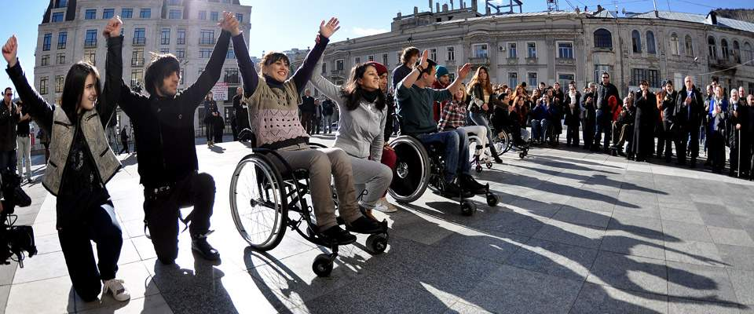

Strategic Planning Process
Following the formal approval of our needs assessment plan, we moved into our strategic planning phase. The first step was to hold listening sessions for key stakeholders of all levels at both organizations. The goals of the listening sessions were to inform stakeholders of the key findings of our needs assessment, to hear from them about ideas for possible solutions and setting priorities, and to generate interest and support for our work over the next year. We held a total of 5 listening sessions. The outline of the listening sessions are included in the table below:
Organization | Participants | When
SVC | -volunteer advocates | July 28, 2015
SVC | -staff and board | July 29, 2015
The Arc | -staff | July 29, 2015
The Arc | -executive leadership | August 3, 2015
The Arc | -Self-Advocate Advisory Committee | August 11, 2015

Listening Sessions Summary

Sexual Violence Center
Our listening sessions with SVC stakeholders highlighted that listening, respect, and safety are topics we should focus on to create a welcoming and supportive environment. Training and building skills to support people with I/DD was identified as a priority for advocates at SVC. The listening sessions identified the following trainings needed for advocates at SVC:
- Build skills to become disability aware
- Develop knowledge around guardianship
- Enhance understanding the intersection of domestic and sexual violence

In addition to advocate training, participants in the listening sessions identified the need for a support group for people with disabilities and access to accommodations for all victims/survivors. Specific examples included the importance of the same advocate supporting people with I/DD, find ways to make the existing hotline more accessible to people with I/DD, metro bus schedules at SVC’s entrance, offering bus tokens, adding activism groups to the resource list given to victims/survivors, and deepening relationships with organizations to offer off-site support groups that are located at accessible sites. Lastly, the physical accessibility of SVC brought up ideas such having a greeter at the entrance, exploring furniture that could easily move to create more space, dimmer switches to control lighting, and counseling rooms that are simple in design.

The Arc
We held listening sessions for three different audiences of stakeholders from The Arc: all staff, executive leadership, and the Self-Advocate Advisory Committee (SAAC). The SAAC is a committee of self-advocates who meet monthly at The Arc to talk about and act on topics such as public policy, education, employment, housing, and safe relationships, among other topics. The group is open to anyone with a disability who has an interest. The collaboration has involved the SAAC by giving presentations on the progress of our grant since our grant started.

Self-Advocate Advisory Committee (SAAC)
Members of the SAAC voiced they like what The Arc currently is doing around its’ abuse prevention efforts. The SAAC recommended developing trainings on sexual violence, improving access to services, and the need for access to different communication methods such as communication boards. They said that they do not have information about how to stop abuse or sexual violence or know how to get help or support to heal, if they are survivors. The SAAC asked the collaboration to develop trainings on the following topics:
- How to get access to services when you don’t have a car
- What is sexual violence?
  - How is it taught? Where?
  - How does it differ from sexual harassment?
  - How do you prove it?
The SAAC shared ideas on how to support persons with I/DD when they are subjected to sexual violence. They stated that it is important that staff have education, training, and experience in services for people with I/DD, self-advocacy, and sexual violence. Printed materials need to accessible and identify information on sexual violence and abuse. Materials should include specific resources to get the support needed and be easily available in community locations. They also requested that communication boards be made available that have the tools to communicate about sexual violence.

Staff at The Arc
Our listening session with The Arc staff resulted in conversations about needs in the areas of staff training; accessible materials; creating welcoming and supportive spaces; outreach to raise awareness of sexual violence and people with I/DD; and organization policies and procedures. Staff saw the need for training on providing a trauma-informed approach and identified the importance of building capacity in order to provide support. This includes taking extra time, learning new skills, building confidence, and expanding knowledge to best support people with I/DD who have been subjected to sexual violence.
We also heard from staff that making changes to the physical spaces at The Arc is important. Some examples offered were multi-language/visual signage, sensory objects offered for calming in the reception and meeting rooms, hosting weekend and evening events, and using plain language with all communications and resources.
The staff highlighted the need for outreach and education to raise awareness of the issue of sexual violence and people with I/DD. It has been the experience of staff that many parents, direct support professionals, and persons with I/DD have a narrow understanding of sexual violence and its impact as it relates to people with I/DD.
Finally, staff identified the need to review formal policies and procedures around abuse and sexual and domestic violence. The policies and procedures must guide the range of responses and supports offered to persons with I/DD who are victims. The development of best practices, safety planning protocols, and how The Arc works with agency partners will need to be developed and/or considered.
We reviewed the information that we gathered from the listening sessions, focus groups, and interviews. As a result, we determined key priority areas to include in our strategic plan. We shared these priorities with our technical assistance providers from the Vera Institute of Justice. Our technical assistance providers guided the collaboration through a two day strategic planning retreat. During this two day planning retreat, we selected our five major key initiatives and discussed long-term initiatives. After our retreat, the collaboration committee met and finalized our key initiatives and established our timeline of tasks with action steps and outcomes to accomplish over the next 16 months.

Strategic Plan Initiatives
Working with our technical assistance providers from the Vera Institute, we selected the following 5 key initiatives for the implementation phase of our grant:
- Staff Comfort and Capacity
- Access and Safety
- Policies and Procedures
- Resources
- Self-Advocates

These initiatives reflect what we heard from people during our needs assessment and also from staff and volunteers during our listening sessions. The goals of our strategic plan will help us to transform our agencies to improve how we support victims/survivors with I/DD with services that are accessible, trauma-informed, and disability aware.
An outline of the key activities and timeline for each initiative is located in Appendix B. We used a 16 month timeline for our initiatives because our plan is to ask for an extension to use grant funds not spent in the 3 year timeframe. We estimate funds for 4 additional months past the end of our grant, September 30, 2016.

Work Groups
In order to succeed with our initiatives, work groups can accomplish a portion of the work in the first two initiatives: staff comfort and capacity and access and safety. This creates buy-in across both organizations, provides opportunities for staff and volunteers to be involved, and supports a wide array of voices included in the creation and decision making process.
Work groups will be made up of staff and interns from The Arc and volunteer advocates from SVC; at minimum, we want 2 representatives from each agency in work groups.
Volunteer advocates at SVC carry out a majority of the advocacy services provided at SVC. Many of the volunteer advocates have been long-time volunteers and know the organization very well. Relying solely on volunteer advocates from SVC creates concerns because of the uncertainty of availability and/or commitment. The timeline for establishing our work groups is included below:
Month 1- Develop orientation materials for work group participants
Month 2- Recruit work group members
Month 3- Orientation for work group members
Month 4- Work groups begin work on initiatives
Additional information about work groups is included below under “structure” for each initiative.

Initiative 1: Staff Comfort and Capacity
Build the competency, knowledge, and skills of The Arc staff and SVC advocates to effectively support and work with victims/survivors with I/DD.
We heard from staff at The Arc and advocates at SVC that there is a great need to get training on the topic of supporting people with I/DD who have been subjected to sexual violence. The training topics selected are what we heard from staff and advocates that are critical for them to learn. The expertise of staff and volunteers from both organizations will be used to develop some of the trainings. Outside experts can provide trainings on topics such as providing trauma-informed services.
We must first clarify the role of Arc staff in supporting victims/survivors of sexual violence. Staff members who participated in the listening session were unclear or believe that responding to sexual violence is outside of their role as an advocate. To better define the role of Arc staff in responding to sexual violence, the collaboration committee will review and make recommendations for revisions of the scopes of services that Arc staff use to guide their work. Scopes state what advocates can and cannot do and outline the advocacy process. The revised scopes will include sexual violence and trauma-informed practices; doing so will help pave the way for transforming or shifting how Arc staff does their work on a daily basis.
We will develop a unique training for staff and volunteers at each organization and will share knowledge and expertise to build staff capacity to support victims/survivors of sexual violence with I/DD. This may include shared trainings. Training recommendations will be shared with each organization’s leaders to create buy-in creating training requirements for all staff and volunteers who may come into contact with victims/survivors of sexual violence.
All trainings will be offered on an ongoing basis to staff and volunteers who have positons that are most likely to require them to interact with victims/survivors of sexual violence. Trainings will take into consideration typical length of time, potential use of recorded webinars or video to be used for staff who are unable to attend scheduled trainings.

Key Activities
- Work with The Arc staff to define their role in supporting victims/survivors of sexual violence with I/DD
- Provide tailored trainings to staff of The Arc on supporting people with I/DD who are or have the potential to be subjected to sexual violence. Training topics to include:
  - Trauma-informed services
  - Best practices for serving survivors
  - Sexual assault in the lives of people with I/DD
  - The role ableism plays in sexual violence against people with disabilities
  - Consensual sexual activity in the lives of people with I/DD
- Provide tailored trainings to advocates of SVC on supporting people with I/DD who are subjected to sexual violence. Training topics to include:
  - Impact of sexual violence on people with disabilities
  - The role ableism plays in sexual violence against people with disabilities
  - Consensual sexual activity in the lives of people with I/DD
  - How to tailor crisis intervention and advocacy to meet the needs of survivors with I/DD

Process for Supporting The Arc Staff in Their Role
Staff at The Arc shared the need to define their role in supporting victims/survivors. To begin to establish this desired support, the current scopes of services and job descriptions for advocates must be reviewed by the collaboration committee. The review is necessary to determine possible sexual violence and trauma-informed gaps and revisions can be made to address gaps and support best practices. Program team supervisors and senior advocates will provide input and feedback to update scopes and job descriptions. The collaboration committee will then publish the revised scopes to bring them to practice and schedule roll out meetings to educate staff about changes. This should bring clarity to The Arc staff about how supporting victims/survivors is within their role.
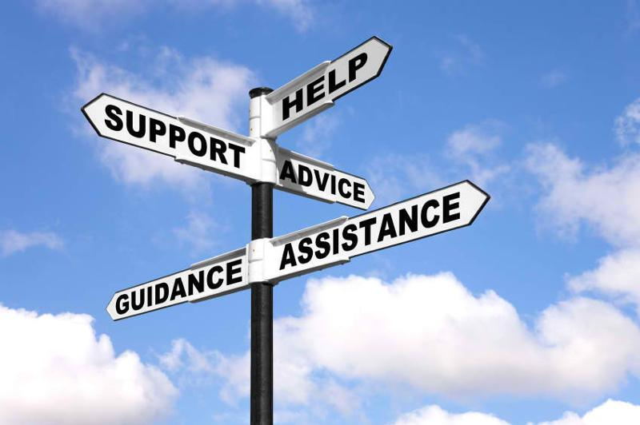

Process for Training The Arc Staff
The first step for training The Arc staff is making decisions around who the audience is, the training topics, and the structure. A work group will be responsible for the process for training both The Arc staff and SVC advocates. The possible training topics, listed under key activities, were collected from listening sessions. Next is approval from program team supervisors, the administration team leads, and the Value Village leadership. The next step consists of reviewing existing trainings, other resources, and the potential use of webinars and/or video. The work group will then create trainings and an evaluation plan.
After receiving OVW approval and buy-in from leadership, the work group can begin recruitment of presenters and panelists and schedule trainings. Once staff participate in and evaluate the training, the work group can then alter the training as necessary. To ensure sustainability, key leadership staff will need to be identified to ensure trainings continue.
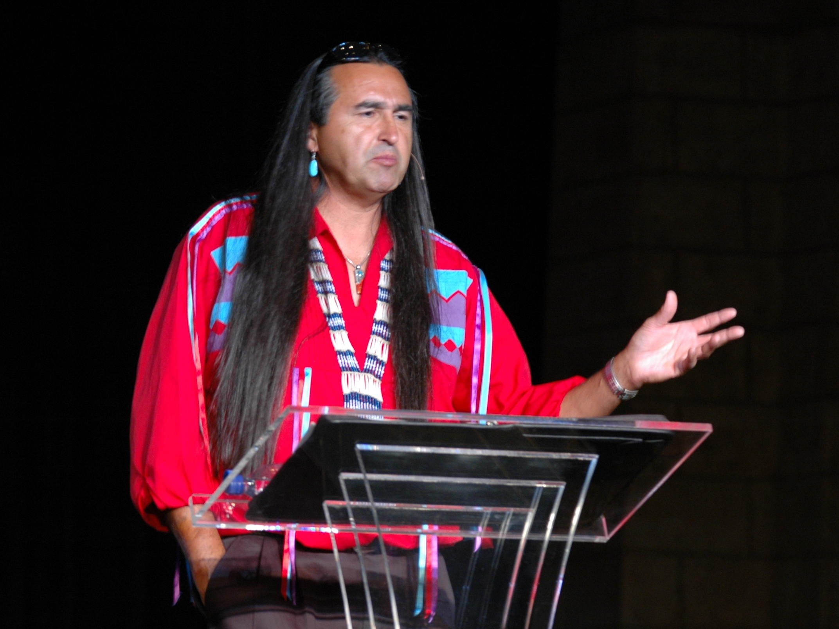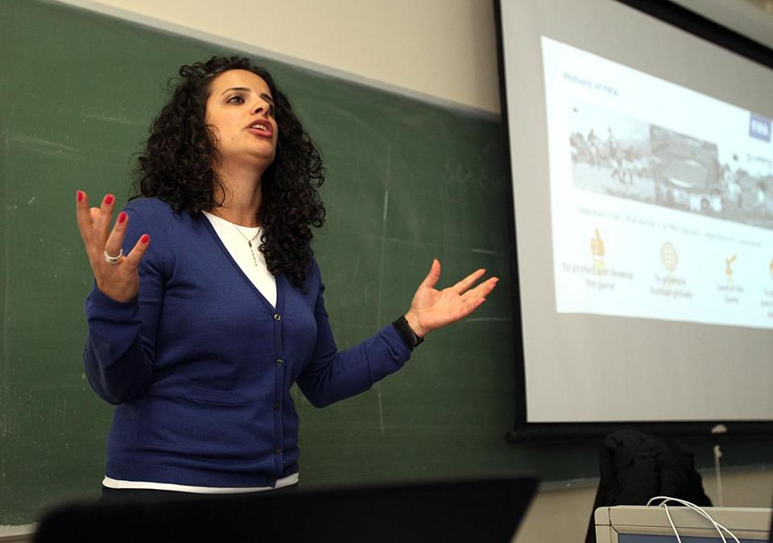

Process for Training SVC Advocates
The process for training SVC mirrors the process above for The Arc. We will account for the unique structure of leadership of SVC in place of what is written for The Arc above.
A detailed chart of the anticipated steps for each key activity and accompanying timeline is included in Appendix B.

Structure
The collaboration committee will be responsible for the first step of changing the scopes of services for staff at The Arc. Senior advocates and program supervisors plan to review the scopes and make any necessary edits. We will also review job descriptions for advocates and make recommendations for changes to job descriptions as needed.
The plan is to establish a work group to develop and provide trainings to staff and advocates at both organizations. The work group will be made up of staff and interns from The Arc and volunteer advocates from SVC. Interested parties are welcome to participate in the work group with a special effort to engage the following groups and individual staff from The Arc:
- Advocates and Programs and Services Supervisors
- Management level staff from Arc Value Village stores (5 local thrift stores that are owned and operated by The Arc)
- Chief Program Officer
- Director of Human Resources
- Administration Team members

We want staff from Arc Value Village stores to participate in work groups to better connect our work with the 5 local thrift stores that are owned and operated by The Arc. We see the Value Village stores as places where staff and volunteers may encounter victims/survivors of sexual violence who may be looking for support. Many of the Value Village staff and volunteers are people with I/DD. By engaging Value Village into our work, we will reach more victims/survivors.
The project co-directors will serve as technical advisors for the work groups and be responsible for orienting work group members. The work group starts its work at month 4. We anticipate the work group to meet at least monthly at alternating locations between The Arc and SVC.

Initiative 2: Access and Safety
Promote access and enhance safety of the physical and communication environments of The Arc and SVC.
The collaboration committee begins by selecting a tool to use to review the physical and communication environments of both organizations. The people who participated in our needs assessment and our listening sessions said that there are needed changes to the physical and communication environment at SVC and The Arc. By conducting a detailed review of both organizations, we will identify changes we can make to help ensure that our services are more safe, welcoming, and accessible.
Once the review is completed and key changes identified, barrier removal and safety enhancement plans for both organizations can be created. The work group, with guidance from the collaboration committee, will be responsible for deciding what to prioritize in the plans. The issues and improvements outlined in these plans will be addressed at both organizations. Once the plans are completed, an annual review process will be established to ensure continuous use of the tool. Then this tool can be used at current locations and, should the time come, be used to help select and assess any new locations.

Key Activities
- Identify a tool for reviewing physical and communication environments that emphasizes universal access and safety.
- Conduct reviews of collaborating organizations.
- Develop Barrier Removal and Safety Enhancement Plans for each organization.
- Establish an annual review process.

Process for Identifying an Access and Safety Tool
This initiative requires a separate work group. The first step will be to identify an access and safety tool from existing tools. Once a tool is selected, we may need to make changes so the tool works for each agency.

Process for Conducting Reviews of Collaborating Organizations
Annual reviews will be scheduled and then, conducted with results brought to the collaboration committee for review and input.

Process for Barrier Removal and Safety Enhancement Development
Barriers and safety can be addressed by first determining each agencies’ priorities. Leadership must meet and review agency priorities. The work group and leadership will meet to compare and negotiate priorities with an outcome of a written plan for each agency.

Process for Establishing an Annual Review Process
After identifying the key staff members at both agencies to be involved in establishing an annual review process, the work group will then, establish future annual review dates. At which time, agencies will develop and sign an updated MOU that includes annual review. An annual review creates sustainability for the needs for access and safety for each organization.
A detailed chart of the anticipated steps for each key activity and accompanying timeline is included in Appendix B.

Structure
The collaboration will establish a work group of staff and interns from The Arc and volunteer advocates from SVC to lead the work of each of the key activities for this initiative with a special effort to engage the following groups and individual staff from The Arc:
- Advocates and Programs and Services Supervisors
- The Self-Advocate Advisory Committee
- Administration Team members
- Managers and supervisors at Arc Value Village stores

The project co-directors will serve as technical advisors for the work groups and be responsible for orienting work group members. The work group starts its work at month 4. We anticipate the work group to meet at least monthly at alternating locations between The Arc and SVC.

Initiative 3: Policies and Procedures
Develop policies and procedures at the Arc and SVC for people with I/DD that increase their safety, confidence, comfort, and empowerment.
We selected two policies and procedures to focus on developing during the implementation phase of our grant—with each organization focusing on the development of one policy and procedure. The Arc needs a policy on mandatory reporting. SVC needs a policy on supported decision making that focuses on consent and guardianship.
Staff at The Arc needs clarity around their role as related to mandatory reporting because there is confusion about staff’s role as related to mandatory reporting. When conducting the Performance Indicator Measurement System we learned that The Arc does not currently have a policy that guides the staff’s role relative to mandatory reporting. Staff’s role must be clear before they expand their efforts to support people with I/DD around sexual violence.
Advocates at SVC identified that they need training and guidance on how to navigate supporting a victim/survivor who has a guardian. We will develop a supported decision making policy that informs advocates on how to best approach issues of guardianship and consent in working with victims/survivors receiving services.

Key Activities
- Develop a mandatory reporting policy and corresponding protocol for The Arc.
- Develop a supported decision making policy around consent and guardianship, and corresponding procedure for SVC.

Process for Mandatory Reporting policy and protocol for The Arc
The collaboration committee will develop a mandatory reporting policy and accompanying protocol for The Arc. We plan to review Minnesota laws and statutes to determine the impact and responsibilities of Arc staff with mandatory reporting. We foresee needing to talk with legal counsel for The Arc to determine The Arc’s responsibility under the Minnesota laws about mandatory reporting and review policies from other similar organizations. Information will be presented to executive leadership throughout the policy development to get feedback and final approval of mandatory reporting obligation of The Arc. Finally, the policy gets submitted to OVW.
After approval, our work to research and develop protocols begins. In order to create culturally responsive protocols, we will ask the Self-Advocate Advisory Committee (SAAC) from The Arc to review proposed protocols. The SAAC can provide feedback on how our protocols can best support self-advocates. The following step is drafting our own protocols and working with leadership to finalize and submit the protocols for OVW approval. Once approved, we will develop and get OVW approval for a training on the new policy and protocols for staff. This results in staff becoming better supported in their role as it relates to mandatory reporting.

Process for Supported Decision Making policy and procedures for SVC
The collaboration committee will develop a supported decision making policy around consent and guardianship and a corresponding procedure for SVC. This work begins by conducting research to better understand supported decision making and how it works in the context of guardianship and consent and consulting with a lawyer who specializes in guardianship issues to receive guidance on creating a policy that includes clear information on the Minnesota laws. The guidance of SVC’s leadership can shape the policy as we review policies of similar organizations. Using the guidance of leadership on what needs to be included in the policy, we will review similar policies of other organizations. The final step is to draft our own policy and work with leadership to finalize and submit the policy for OVW approval.
After approval, our work to research and develop procedures begins. In order to create culturally responsive procedures, we will ask the Self-Advocate Advisory Committee (SAAC) from The Arc to review proposed procedures. The SAAC can provide feedback on how our procedures can best support self-advocates. The following step is drafting our own protocols and working with leadership to finalize and submit the protocols for OVW approval. Once approved, we will develop and get OVW approval for a training on the new policy and procedures for advocates. This results in advocates becoming better supported in their role as it relates to guardianship and consent.
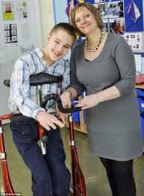
Since the collaboration committee is not able to make decisions about approving policies and procedures, we will consult the leadership at both organizations by presenting information we gather about best practices and examples of policies and procedures. We will make recommendations to leadership and use their feedback and guidance to implement effective policies and procedures within each organization.

A detailed chart of the anticipated steps for each key activity and accompanying timeline is included in Appendix B.

Structure
The collaboration committee is responsible for all of the work for this initiative. During implementation our collaboration committee plans to remain the same as during our planning and development phase. The collaboration committee will continue to meet every other week at alternating agencies for meetings.
The project co-directors’ responsibilities include driving the work of this initiative with input and support from the rest of the collaboration committee. We will seek assistance from staff at either organization should we need assistance with understanding current policies and procedures or help with creating new policies and procedures. We consider these staff members key informants and plan to have them attend collaboration meetings or advise the collaboration as needed.

Initiative 4: Resources
Develop resources for The Arc and SVC to enhance the ability of staff to effectively work with victims/survivors with I/DD.

Many of the people we talked to during our needs assessment stated that there needs to be more accessible information provided when they receive services. The most common suggestion was to provide visual aids. A picture guide for sexual assault exams is a tool that is greatly needed by advocates at SVC, as it will enhance the experiences of victims/survivors with I/DD. Our plan is to modify an existing guide for our purposes; thus, we will review existing picture guides such as the one developed by Illinois Imagines.
The safety planning protocol for The Arc accompanies the training that is provided through Initiative 1. The work group will develop a protocol to guide staff on how to conduct basic safety planning with people who disclose that they have been subjected to sexual violence. The protocol focuses on addressing immediate safety needs and how to make appropriate referrals that will best support the person seeking safety.

Key Activities
- Develop a picture guide for the sexual assault exam for use by SVC staff/volunteers.
- Create a safety planning protocol for Arc staff that enables them to support survivors with I/DD in developing a plan to address immediate safety needs.

Process for developing a picture guide for a sexual assault exam
The collaboration committee will develop a picture guide for use by advocates at SVC as an aid to explain the sexual assault exam process to victims/survivors with I/DD. However, the picture guide will be available for advocates to provide to any victim/survivor. We begin by reviewing the exam procedure used in Hennepin County. The collaboration committee will locate existing guides such as the guide developed by Illinois Imagines and review the guides, choosing an existing guide to modify for our unique purposes. The SAAC and Sexual Assault Response Services (SARS) nurses can provide feedback after reviewing the guide. Once finalized, we will submit the guide to OVW for approval and training of advocates and relevant staff at The Arc will follow.
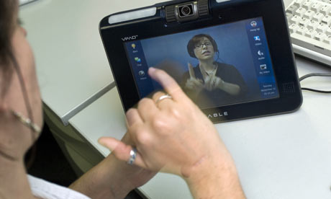

Process for creating a safety planning protocol for The Arc
The work group assigned to initiative 1 will develop the safety planning protocol for The Arc. The protocol can be developed at the same time as development of staff and volunteer trainings. They will start by reviewing existing safety planning protocols from other organizations and researching best practices in safety planning protocols. The work group will develop a draft protocol and then, work with senior advocates and program and services supervisors to revise the protocol. Once they have a draft protocol, they will submit the draft to the collaboration committee. The collaboration committee’s responsibility includes reviewing the draft and providing feedback on an ongoing basis until a final version is approved. Upon receiving approval from OVW, a training will follow.

A detailed chart of the anticipated steps for each key activity and accompanying timeline is included in Appendix B.

Structure
The collaboration committee will be responsible for developing the picture guide for sexual assault exams, working with Sexual Assault Response (SARS) nurses and the Self-Advocate Advisory Committee (SAAC) from The Arc.
The work group established for Initiative 1 also takes on the work of developing a safety planning protocol for The Arc. The protocol will be introduced to staff at The Arc at the same time of their trainings to increase staff comfort and capacity.

Initiative 5: Self-Advocates
Build the ability of self advocates and The Arc and SVC to work together to address sexual violence in the lives of people with I/DD.
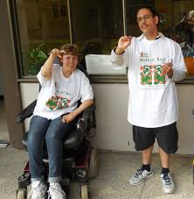
We heard from members of the SAAC during our listening session that there is a need for training self-advocates on how sexual violence impacts the lives of people with I/DD. Members of the SAAC wanted training on what sexual violence is, what to do if you or someone you know is subjected to sexual violence, and where to get help if it happens. This was also brought up by staff at The Arc as an important opportunity that the collaboration could offer. The collaboration committee decided that access to such important information is greatly needed by self-advocates in our community.

Key Activities
- Develop opportunities for self-advocates to learn about sexual violence in the lives of people with I/DD.

Process for developing opportunities for self-advocates to learn about sexual violence
The collaboration committee’s role includes being in charge of developing opportunities for self-advocates to learn about sexual violence. We will start by reviewing existing trainings and either modify an existing training or develop our own training based on key elements of other trainings. Our plan is to create a training that is 4-8 sessions in duration and can be completed within two months. Training topics will include, but, are not limited to:
- What is sexual violence
- What to do when you or someone you know is subjected to sexual violence
- Where to go for help
- How to talk to friends and family about sexual violence

We will also develop an evaluation plan for the training at the same time we are developing the training.
Once we have created the training, we will ask the SAAC and other self-advocacy organizations for their feedback on the training. We will adjust the training according to the feedback we receive. Once finalized, submission to OVW for approval follows. After we receive approval, we can select and train facilitators for the training sessions. Once we have started to train the facilitators we will secure locations for trainings, develop a marketing plan, and do outreach to self-advocacy organizations and groups in the Twin Cities area.
Lastly, we will hold the training sessions and complete the training sessions with a detailed evaluation. We plan to use the information from the evaluations to make adjustments for future sessions.
At the time of the writing of this strategic plan we are exploring piloting a leadership training for self-advocates that was developed by the Vera Institute of Justice. If we are selected to pilot the training, our work plan will change for this initiative and an updated strategic plan will be provided to OVW.

A detailed chart of the anticipated steps for the key activity and accompanying timeline is included in Appendix B.

Structure
The collaboration committee will be responsible for developing and starting opportunities for self-advocates to learn about sexual violence. We decided to start this initiative at month 5 so that we may devote the first months of implementation to starting our work groups for initiative 1 and 2.
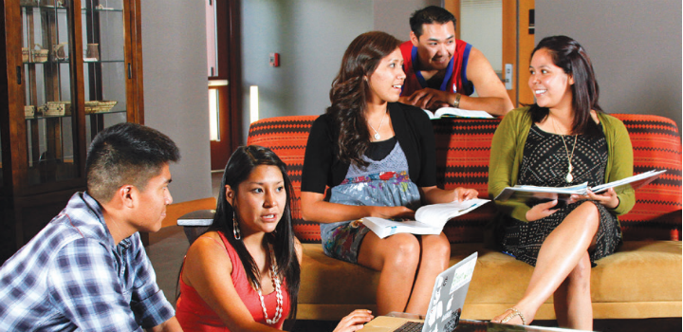

Long-Term Initiatives
We define long-term as month 17 and beyond in our work.
All of our short-term initiatives are interconnected. We are going to take the lessons we learn from our process in the implementation phase of our grant to expand our work in the long-term. We will use our collective knowledge to continue to improve services for victims/survivors of sexual violence who have I/DD.
We value expanding our work of Initiative 1, staff comfort and capacity. We will use the information we gathered from the training evaluations to revise and improve the trainings. We plan to establish an ongoing training schedule so that staff and volunteers receive the training within a timely manner. We will use what we learn from the process of creating policies and procedures in the short-term and apply those new skills to developing additional policies and procedures in the long-term. Possible policies and procedures we may create for The Arc include (1) screening for violence or abuse and (2) serving both people who do harm and people who are harmed. Possible policies and procedures we may create for SVC include (1) universal screening for accommodation needs and (2) service animals.
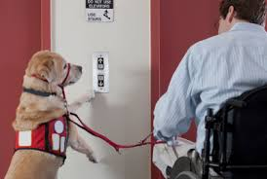

Using what we learned by developing a picture guide for sexual assault exams in the short-term we will look to develop additional picture guides in the long-term. We may explore the development of picture guides for topics such as going to court, attending a support group, or contacting law enforcement.
The training for self-advocates that we implement in the short-term will pave the way for beginning support groups for self-advocates in the long-term. Through the training process, leaders who are self-advocates will emerge and will help to explore the development of a support group for self-advocates.

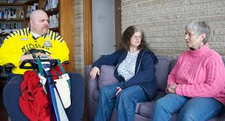

We value taking what we learned during the short-term and applying it to the larger goal of expanding our collaboration to other organizations. We will share with other organizations the lessons we learned and the tools we developed to help them improve their services for victims/survivors with I/DD. Through our needs assessment process we heard many of the people we talked to say that they did not have good interactions with the police. We also heard multiple parents/guardians of people with I/DD say that they were concerned about the person they were supporting interacting with the police since the police might not understand them and react by using physical force. The collaboration would like to expand its work into partnering with law enforcement in the long-term.
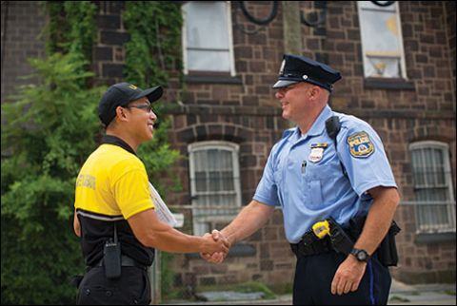

Sustainability
We understand that turnover, changes in organizational culture, and shifts in priorities happen frequently in the nonprofit sector. We will build sustainability into every aspect of our initiatives through a number of strategies and tactics. Every initiative helps to make a cultural change at each agency, which impacts long-term change. An example of this can be seen through Initiative 3, policies and procedures. We will establish new policies and procedures and enhance existing policies and procedures using what we have learned as a collaboration. Another example is seen through the collaboration’s engagement of staff and volunteers in work groups; by doing so, we share the mission and vision of the collaboration. This deepens the commitment to providing access and safety to victims/survivors with I/DD across both organizations.
We will ensure a clear commitment to training and coordination of services through an annually updated MOU between SVC and The Arc. We plan to outline our obligations and define our referral processes to ensure wrap-around services for victims/survivors with I/DD. By establishing our commitment to continue to work together through an annually updated MOU, we will ensure the sustainability of our collaboration.
We are committed to achieving our vision of creating the best possible services for people with I/DD who have been affected by sexual violence. As we have seen and heard numerous times since the start of our grant, there is a great need in our community to better serve victims/survivors of sexual violence with I/DD. This grant has created a strong and lasting partnership between The Arc and SVC. During implementation we will continue to strengthen our partnership while putting the needs of victims/survivors with I/DD at the forefront of our work as we make lasting changes that focus the work of both agencies on improving services for victims/survivors.
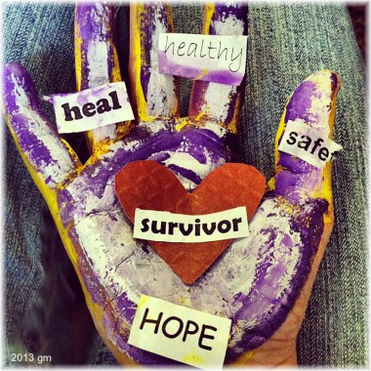

Conclusion
The work we set out to accomplish in the implementation phase of our grant will mold the culture and capacity of our agencies and will improve services for victims/survivors of sexual violence with I/DD. The initiatives outlined in this plan provide the steps needed to continue to work towards our mission.
Our collaboration will improve how we support victims/​survivors with I/DD. We will work together to provide services that respect and empower victims. We will help victims/survivors get the skills and resources they need to heal.

Appendix

Appendix A: Performance Indicator Measurement System Scores
The Arc had a total overall score of 17%, an average of the scores The Arc received in six areas, as listed below:
Basket 1: Responsibility- Agency recognizes its duty to address domestic and sexual violence in the lives of people with disabilities. The Arc scored 16.667%. This basket highlights areas that are a priority for The Arc. The Arc may explore increasing staff knowledge and making programming decisions based on current data. The Arc could bolster staff ability to support victims/survivors with I/DD as they use systems of support.
Basket 2: Partnerships- Agency works closely with relevant organizations to enhance its ability to address domestic and sexual violence in the lives of people it serves. The Arc scored 37.5%. The Arc scored higher in this area because of its partner in this collaboration. There are additional partnerships to explore and develop with law enforcement and domestic violence agencies.
Basket 3- Policies- Agency’s written policies establish expectations for how the organization addresses domestic and sexual victimization among the people it serves. The Arc scored 18.75%. This basket highlights the need to develop policies that guide how The Arc will support people with I/DD who are victims/survivors of domestic and sexual violence. This will be a priority for The Arc.
Basket 4- Material Resources- Agency’s physical infrastructure prioritizes safety and supports service users to disclose domestic and sexual violence. The Arc scored 12.5%. The Arc may review these indicators as they relate to The Arc’s information, assistance, and advocacy services. Most of the time, The Arc provides services in the community and not at The Arc offices.
Basket 5- Human Resources- Agency’s employment and staff development practices build capacity to address domestic and sexual victimization among the people it serves. The Arc scored 12.5%. This basket highlighted areas that are not currently addressed in employment policies around workplace domestic violence. The Arc will explore making these important policy changes.
Basket 6- Procedures- Agency has written protocols that guides how its staff members address domestic and sexual violence. The Arc scored 0.0%. The Arc identifies this basket as a top priority. The Arc may review and improve mandated reporting, safety planning, and informed referrals procedures.

SVC had a total overall score of 8%, an average of the scores SVC received in six areas, as listed below:
Basket 1- Responsibility- Agency recognizes duty to serve survivors of sexual violence with disabilities and Deaf survivors. SVC scored 12.5%. This basket is a main focus for SVC going forward in this project. SVC collects data on victim/survivors with disabilities, but this information is not prepared into reports or used to improve SVC's overall capacity to support these survivors. This is a missed opportunity that should be addressed.
Basket 2- Partnerships- Agency works closely with relevant organizations to enhance its ability to meet the needs of survivors of sexual violence who have disabilities and Deaf survivors. SVC scored 25.0%.This is a higher scoring basket for SVC because of SVC’s partnership with The Arc. SVC will explore developing partnerships with more disabilities service agencies.
Basket 3- Policies- Agency’s written policies ensure accessible and inclusive services are provided to sexual violence survivors with disabilities and Deaf survivors. SVC scored 0.0%. This basket represents a great need SVC. SVC may bolster policies to improve the agency’s capacity to better serve survivors with disabilities.
Basket 4- Material Resources- Agency’s physical infrastructure is accessible to survivors with disabilities and Deaf survivors. SVC scored 6.25%. This is an opportunity for growth for SVC. As SVC staff learns more about accommodations, it will explore options on making improvements to its physical infrastructure.
Basket 5- Human Resources- Agency’s employment and staff development practices build staff capacity to address sexual violence against people with disabilities and Deaf individuals. SVC scored 6.25%. SVC will explore options to develop more disability-inclusive hiring practices. More may be done to connect staff with more training opportunities.
Basket 6- Programmatic Resources and Activities- Agency’s programmatic resources and activities account for the unique needs of people with disabilities and Deaf people. SVC scored 4.17%. Work on this basket will be a top priority for SVC throughout the work of this collaboration. This is a great opportunity for growth for SVC.

Note: The information collection guides and corresponding questions were specific for each organization

Appendix B: Detailed Timeline for Initiatives

Initiative 1: Staff Comfort and Capacity
 |  |  | Who is Responsible? |  | Timeline (months)
Key Activities | Outcomes | Deliverables | Collaboration | Work Group | 1 | 2 | 3 | 4 | 5 | 6 | 7 | 8 | 9 | 10 | 11 | 12 | 13 | 14 | 15 | 16
Work with staff of The Arc to define their role in supporting victims/survivors of sexual violence
1. Review current scopes of services and job descriptions of advocates | Review scopes and job descriptions |  | X |  | X
2. Determine gaps as related to sexual violence and being trauma-informed | Identify gaps on scopes |  | X |  | X
3. Revise scopes to include sexual violence and trauma-informed practices | Revise scopes |  | X |  |  | X
4. Present proposed changes to scopes and job descriptions to Program Team supervisor team (if job descriptions change, must go through Human Resources) | Approval from leadership |  | X |  |  |  | X
Key Activities | Outcomes | Deliverables | Collaboration | Work Group | 1 | 2 | 3 | 4 | 5 | 6 | 7 | 8 | 9 | 10 | 11 | 12 | 13 | 14 | 15 | 16
5. Get feedback from senior advocates on revised scopes | Feedback from senior advocates |  | X |  |  |  | X
6. Publish revised scopes | Post scopes on intranet | Submit revised scopes to OVW | X |  |  |  |  | X
7. Schedule and hold roll-out meetings | Meeting for Program Team to inform of scopes |  | X |  |  |  |  | X
Provide trainings to staff of The Arc
1. Decide on audience, training topics and structure | Identify topics and structure |  | X |  |  |  | X
2. Get approval from Program Team supervisor team, Admin team lead, and store managers leadership | Approval from leadership |  | X |  |  |  |  | X
3. Research existing trainings/develop training and evaluation plan | Select and revise training |  |  | X |  |  |  | X | X | X
4. Collaboration approves training | Approval from collaboration |  | X |  |  |  |  |  |  |  | X
5. Submit training to OVW; obtain approval |  | Training submitted to OVW | X |  |  |  |  |  |  |  |  | X
Key Activities | Outcomes | Deliverables | Collaboration | Work Group | 1 | 2 | 3 | 4 | 5 | 6 | 7 | 8 | 9 | 10 | 11 | 12 | 13 | 14 | 15 | 16
6. Determine presenters/panelists | Select presenters/panelists |  |  | X |  |  |  |  |  |  |  | X | X
7. Develop training schedule and gain buy-in to make training components required dependent on role | Determine schedule and make training components mandatory based on role |  |  | X |  |  |  |  |  |  |  |  | X
8. Communicate training schedule | Post schedule |  |  | X |  |  |  |  |  |  |  |  |  | X
9. Conduct training | Complete trainings |  |  | X |  |  |  |  |  |  |  |  |  |  | X
10. Evaluate training | Evaluation of trainings | Submit evaluation results to OVW | X | X |  |  |  |  |  |  |  |  |  |  |  | X
11. Train the trainers | Trainers pass on knowledge to other potential trainers | Submit training materials to OVW | X | X |  |  |  |  |  |  |  |  |  |  |  |  | X | X
12. Establish ongoing semi-annual schedule of trainings | Schedule of future trainings |  |  | X |  |  |  |  |  |  |  |  |  |  |  |  |  |  | X
Provide trainings to advocates of SVC
1. Decide on training topics and structure | Identify topics and structure |  | X |  |  |  | X
Key Activities | Outcomes | Deliverables | Collaboration | Work Group | 1 | 2 | 3 | 4 | 5 | 6 | 7 | 8 | 9 | 10 | 11 | 12 | 13 | 14 | 15 | 16
2. Get approval from training coordinator | Approval of training by SVC |  | X |  |  |  |  | X
3. Research existing trainings/develop training and evaluation plan | Select and revise training |  |  | X |  |  |  | X | X | X
4. Collaboration approves training | Approval from collaboration |  | X |  |  |  |  |  |  |  | X
5. Submit training to OVW; obtain approval |  | Submit training to OVW | X |  |  |  |  |  |  |  |  | X
6. Determine presenters/panelists | Select presenters/panelists |  |  | X |  |  |  |  |  |  |  | X | X
7. Develop training schedule and gain buy-in to make training required | Schedule is set and training is mandatory for advocates |  |  | X |  |  |  |  |  |  |  |  | X
8. Message advocates about training | Post schedule |  |  | X |  |  |  |  |  |  |  |  |  | X
9. Conduct training | Complete trainings |  |  | X |  |  |  |  |  |  |  |  |  |  | X
10. Evaluate training | Evaluation of trainings | Submit evaluation results to OVW | X | X |  |  |  |  |  |  |  |  |  |  |  | X
11. Train the trainers | Trainers pass on knowledge to other potential trainers | Submit training materials to OVW | X | X |  |  |  |  |  |  |  |  |  |  |  |  | X | X
Key Activities | Outcomes | Deliverables | Collaboration | Work Group | 1 | 2 | 3 | 4 | 5 | 6 | 7 | 8 | 9 | 10 | 11 | 12 | 13 | 14 | 15 | 16
12. Establish ongoing semi-annual schedule of trainings | Schedule of future trainings |  |  | X |  |  |  |  |  |  |  |  |  |  |  |  |  |  | X

Initiative 2: Access and Safety

 |  |  | Who is Responsible? |  | Timeline (months)
Key Activities | Outcomes | Deliverables | Collaboration | Work Group | 1 | 2 | 3 | 4 | 5 | 6 | 7 | 8 | 9 | 10 | 11 | 12 | 13 | 14 | 15 | 16
Identify tool for reviewing safety and access of each agency
1. Identify and review known tools | Review existing tools |  |  | X |  |  |  | X
2. Select tools to be used and adapted | Select tools |  |  | X |  |  |  |  | X
3. Adapt tools to use at each agency | Adapt tools |  |  | X |  |  |  |  |  | X
Conduct review of each agency
1. Schedule review for each agency | Schedule review |  |  | X |  |  |  |  |  |  | X
2. Conduct reviews at each agency | Complete review |  |  | X |  |  |  |  |  |  |  | X
3. Bring results to collaboration for review and input | Present findings to collaboration |  |  | X |  |  |  |  |  |  |  |  | X
Key Activities | Outcomes | Deliverables | Collaboration | Work Group | 1 | 2 | 3 | 4 | 5 | 6 | 7 | 8 | 9 | 10 | 11 | 12 | 13 | 14 | 15 | 16
Develop barrier removal and safety enhancement plans for each agency
1. Determine priorities for each agency | Determine priorities |  |  | X |  |  |  |  |  |  |  |  |  | X
2. Conduct meetings with leadership for each agency to review priorities | Receive feedback from leadership |  |  | X |  |  |  |  |  |  |  |  |  |  | X
3. Reconcile team priorities with leadership priorities | Identify priorities |  |  | X |  |  |  |  |  |  |  |  |  |  | X
4. Write plan for each agency | Write plan |  |  | X |  |  |  |  |  |  |  |  |  |  |  | X | X
Establish process for annual review
1. Identify core positions that would need to be part of review | Identify core group |  |  | X |  |  |  |  |  |  |  |  |  |  |  |  |  | X
2. Establish dates of annual reviews | Set schedule |  |  | X |  |  |  |  |  |  |  |  |  |  |  |  |  |  | X
3. Develop and sign MOU regarding annual review between SVC and The Arc | Write MOU | Send MOU to OVW | X | X |  |  |  |  |  |  |  |  |  |  |  |  |  |  |  | X

Initiative 3: Policies and Procedures
 |  |  | Who is Responsible? |  | Timeline (months)
Key Activities | Outcomes | Deliverables | Collaboration | Work Group | 1 | 2 | 3 | 4 | 5 | 6 | 7 | 8 | 9 | 10 | 11 | 12 | 13 | 14 | 15 | 16
Develop policy and procedure for The Arc regarding mandatory reporting
Policy
1. Conduct research to better understand responsibilities | Complete research |  | X |  | X | X
2. Consult with legal council | Receive guidance from legal council |  | X |  |  | X
3. Leadership decides/determines responsibilities | Leadership decide scope of policy |  | X |  |  |  | X
4. Review existing policies from other organizations; determine key elements to include in policy | Review additional policies |  | X |  |  |  |  | X | X
5. Create and review draft policy | Create policy |  | X |  |  |  |  |  |  | X | X | X
6. Finalize draft policy | Finalize policy |  | X |  |  |  |  |  |  |  |  |  | X
7. Submit to leadership | Approval from leadership |  | X |  |  |  |  |  |  |  |  |  |  | X
Key Activities | Outcomes | Deliverables | Collaboration | Work Group | 1 | 2 | 3 | 4 | 5 | 6 | 7 | 8 | 9 | 10 | 11 | 12 | 13 | 14 | 15 | 16
8. Leadership provides feedback, revise policy (repeat as needed) | Finalize policy |  | X |  |  |  |  |  |  |  |  |  |  |  | X | X
9. Submit to OVW |  | Submit policy to OVW | X |  |  |  |  |  |  |  |  |  |  |  |  |  | X
Procedure
1. Understand scope of policy | Review policy |  | X |  |  |  |  |  |  |  |  |  | X
2. Review protocols of other organizations | Review of other protocols |  | X |  |  |  |  |  |  |  |  |  |  | X
3. Draft protocol | Create protocol |  | X |  |  |  |  |  |  |  |  |  |  |  | X | X
4. Present to SAAC and get feedback | SAAC presentation |  | X |  |  |  |  |  |  |  |  |  |  |  |  |  | X
5. Approval by directors | Approval from directors | Submit protocol to OVW | X |  |  |  |  |  |  |  |  |  |  |  |  |  | X
6. Develop training on procedures | Develop trainings | Submit trainings to OVW | X |  |  |  |  |  |  |  |  |  |  |  |  |  |  | X | X
7. Train staff | Conduct trainings |  | X |  |  |  |  |  |  |  |  |  |  |  |  |  |  |  |  | X
Develop policy and procedure for SVC on supported decision making
Policy
1. Conduct research to better understand responsibilities | Complete research |  | X |  | X | X
Key Activities | Outcomes | Deliverables | Collaboration | Work Group | 1 | 2 | 3 | 4 | 5 | 6 | 7 | 8 | 9 | 10 | 11 | 12 | 13 | 14 | 15 | 16
2. Consult with legal council | Receive guidance from legal council |  | X |  |  | X
3. Leadership decides/determines responsibilities | Leadership decide scope of policy |  | X |  |  |  | X
4. Review existing policies from other organizations; determine key elements to include in policy | Review additional policies |  | X |  |  |  |  | X | X
5. Create and review draft policy | Create policy |  | X |  |  |  |  |  |  | X | X | X
6. Finalize draft policy | Finalize policy |  | X |  |  |  |  |  |  |  |  |  | X
7. Submit to leadership | Approval from leadership |  | X |  |  |  |  |  |  |  |  |  |  | X
8. Leadership provides feedback, revise policy (repeat as needed) | Finalize policy |  | X |  |  |  |  |  |  |  |  |  |  |  | X | X
9. Submit to OVW |  | Submit policy to OVW | X |  |  |  |  |  |  |  |  |  |  |  |  |  | X
Procedure
1. Understand scope of policy | Review policy |  | X |  |  |  |  |  |  |  |  |  | X
2. Review procedures of other organizations | Review of other procedures |  | X |  |  |  |  |  |  |  |  |  |  | X
3. Draft procedures | Create procedures |  | X |  |  |  |  |  |  |  |  |  |  |  | X | X
4 Present to SAAC and get feedback | SAAC presentation |  | X |  |  |  |  |  |  |  |  |  |  |  |  |  | X
Key Activities | Outcomes | Deliverables | Collaboration | Work Group | 1 | 2 | 3 | 4 | 5 | 6 | 7 | 8 | 9 | 10 | 11 | 12 | 13 | 14 | 15 | 16
5. Approval by leadership | Approval from leadership | Submit procedures to OVW | X |  |  |  |  |  |  |  |  |  |  |  |  |  | X
6. Develop training on procedures | Develop trainings | Submit trainings to OVW | X |  |  |  |  |  |  |  |  |  |  |  |  |  |  | X | X
7. Train staff | Conduct trainings |  | X |  |  |  |  |  |  |  |  |  |  |  |  |  |  |  |  | X

Initiative 4: Resources
 |  |  | Who is Responsible? |  | Timeline (months)
Key Activities | Outcomes | Deliverables | Collaboration | Work Group | 1 | 2 | 3 | 4 | 5 | 6 | 7 | 8 | 9 | 10 | 11 | 12 | 13 | 14 | 15 | 16
Develop a picture guide for sexual assault exams for SVC
1. Review exam procedure | Identify existing procedure |  | X |  | X
2. Locate existing guides | Identify existing guides |  | X |  | X
Key Activities | Outcomes | Deliverables | Collaboration | Work Group | 1 | 2 | 3 | 4 | 5 | 6 | 7 | 8 | 9 | 10 | 11 | 12 | 13 | 14 | 15 | 16
3. Research best practices in creating picture guides | Determine best practices |  | X |  |  | X
4. Review pictures with SAAC and get feedback | Feedback from SAAC |  | X |  |  |  | X
5. Review guide with SARS nurses and get feedback | Feedback from SARS |  | X |  |  |  | X
6. Revise and finalize guide | Finalize guide |  | X |  |  |  |  | X
7. Submit to OVW and get approval |  | Submit guide to OVW | X |  |  |  |  | X
8. Incorporate into trainings | Train advocates |  | X |  |  |  |  |  | X
Create a safety planning protocol for The Arc
1. Review existing protocols | Review protocols |  |  | X |  |  |  | X
2. Research best practices in safety planning protocols | Determine best practices |  |  | X |  |  |  | X
3. Develop protocol | Develop protocol |  |  | X |  |  |  |  | X | X
4. Submit protocol for feedback from senior advocates and Program Team supervisor team |  |  |  | X |  |  |  |  |  | X
5. Revise protocol based on feedback (repeat as needed) |  |  |  | X |  |  |  |  |  |  | X
6. Submit to collaboration committee for feedback | Feedback from collaboration |  |  | X |  |  |  |  |  |  |  | X
7. Revise and resubmit to collaboration (repeat as needed) | Revise and get approval from collaboration |  |  | X |  |  |  |  |  |  |  |  | X | X
Key Activities | Outcomes | Deliverables | Collaboration | Work Group | 1 | 2 | 3 | 4 | 5 | 6 | 7 | 8 | 9 | 10 | 11 | 12 | 13 | 14 | 15 | 16
8. Revise and finalize protocol | Finalize protocol |  |  | X |  |  |  |  |  |  |  |  |  | X
9. Submit to OVW and get approval |  | Submit protocol to OVW | X |  |  |  |  |  |  |  |  |  |  | X
10. Train staff on protocol | Hold staff training session |  |  | X |  |  |  |  |  |  |  |  |  |  | X

Initiative 5: Self-Advocates
 |  |  | Who is Responsible? |  | Timeline (months)
Key Activities | Outcomes | Deliverables | Collaboration | Work Group | 1 | 2 | 3 | 4 | 5 | 6 | 7 | 8 | 9 | 10 | 11 | 12 | 13 | 14 | 15 | 16
Develop opportunities for self-advocates to learn about sexual assault in the lives of people with I/DD
1. Review existing trainings and determine key elements | Review trainings |  | X |  |  |  |  |  | X
2. Create/modify trainings | Create presentation |  |  |  |  |  |  |  | X | X | X
Key Activities | Outcomes | Deliverables | Collaboration | Work Group | 1 | 2 | 3 | 4 | 5 | 6 | 7 | 8 | 9 | 10 | 11 | 12 | 13 | 14 | 15 | 16
3. Review training with self-advocates, other self-advocacy organizations (revise as needed) | Review training with other organizations |  | X |  |  |  |  |  |  |  |  | X
4. Finalize training and evaluation plan | Training and evaluation plan finalized |  | X |  |  |  |  |  |  |  |  |  | X
5. Submit to OVW for approval |  | Submit training to OVW | X |  |  |  |  |  |  |  |  |  | X
6. Select facilitators | Choose facilitators |  | X |  |  |  |  |  |  |  |  |  |  | X | X
7. Train facilitators | Train facilitators |  | X |  |  |  |  |  |  |  |  |  |  |  |  | X | X
8. Develop and implement outreach plan to connect with self-advocate groups | Develop marketing plan
9. Advertise trainings | Advertise trainings |  | X |  |  |  |  |  |  |  |  |  |  |  |  | X | X
10. Hold trainings (anticipated 4-8 meetings held over 1-2 months) | Deliver a minimum of 4 training sessions to self-advocates over the next 12 months |  | X |  |  |  |  |  |  |  |  |  |  |  |  |  |  | X | X
11. Evaluation | Conduct evaluation of trainings |  | X |  |  |  |  |  |  |  |  |  |  |  |  |  |  |  |  | X

As described by the Office on Violence on Women

