Mass Rights for Change Charter

An old fashioned scroll with the title written with a quill and at the bottom deep red wax melted into a seal with the letters MRfC in gold stamped onto it.

This project is supported by Grant No. 2017-FW-AX-K004 awarded by the Office on Violence Against Women, U.S. Department of Justice. The opinions, findings, conclusions, and recommendations expressed in this publication/exhibition are those of the author(s) and do not necessarily reflect the views of the Department of Justice, Office on Violence Against Women. **Table of Contents**

3

7

9

18

19

19

20

22

25

30

32

33

35

36

42

43

44

Forward (What must be said before we begin)………………………..

Introduction …………………………………………………………...……………..

The Collaboration and Its Partners…………………………………………..

Vision ………………………………………………………………….…….…………..

Mission …………………………………………………………..………….………….

Values ……………………………………………………………………….…………..

Assumptions ………………………………………………………………………….

Agreements/What we promise to do ……………………………………..

Communication Plan ………………………………….……………………….….

Privacy …………………………………………………….………………..……………

Decision-Making ………………………………………………..…………………...

What to Do When We Disagree ………………………………………….…..

Work Plan ……………………………………………………………………………...

Glossary ……………………………………………………………….………………..

Appendix A …………………………………………………………………………….

Appendix B ……………………………………………………………………………..

References ……………………………………………………………………………..

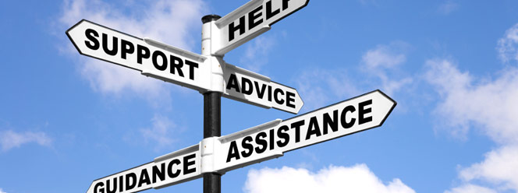Nothing about us without us

Drawn person using a wheelchair and a chain that goes from one arm to the other being broken.Hand drawn tree with labelled leaves

A tree that has many branches and the leaves say: Believe, Empower, Equality, Dignity, Change, Inspire, Pride, Educate, Respect, Advocate, and ConfidenceNothing About us Without Us Logo

A sign of Nothing About Us Without Us being held by two hand drawn people who are part of a group of 10 drawn people representing people with intellectual and developmental disabilities.**Forward**

***What Must be Said Before We Begin***

The Office on Violence Against Women (OVW) granted our group, money, resources and a support[1]* system to grow our collaboration into something special. In the following pages you'll learn about our collaboration of three very diverse agencies, and the steps we have taken and agreed to, in order to best work together on this project and into the future. We will tell you why we have come together, who we are and what we are going to do. We will show how this grant will help us to achieve some very helpful and significant improvements in services to survivors[2]* of sexual violence[3]*, specifically those who have I/DD. The letters I/DD stand for Intellectual/Developmental Disability[4]*.

Jar with a label

Label on a jar that says "labels are for jars..." Underneath the jar it says NOT PEOPLEIn order to introduce this project, before even beginning to write or present about it, we have to start off with the concept of I/DD. We are a group of people with I/DD and the rest are allies. The fact is, for many people with I/DD, this label, the way it is worded and written, is hard to take. Therefore, to begin to trust, listen and work together to achieve great changes, the issues of labels and how to talk about this work became the first focus of the collaboration. This is the reason we need a “forward” to start our charter. We must first talk about labels if we are going to need to use them in our charter.

Our document may be different than other collaborations. As part of building our team and in order to work collaboratively, we have had to come together and discuss how beliefs and ideas are shaped by the language we use, and the limits we have with language. For example, although we agreed that the term I/DD seems to be the most useful one to use, because it is most familiar within society, it could be used negatively as another label to highlight differences and to separate people. People First[5]* language is part of the history of people with I/DD. A common motto used is: “We are people first. We are more alike than different. Our disability[6]* comes second!”

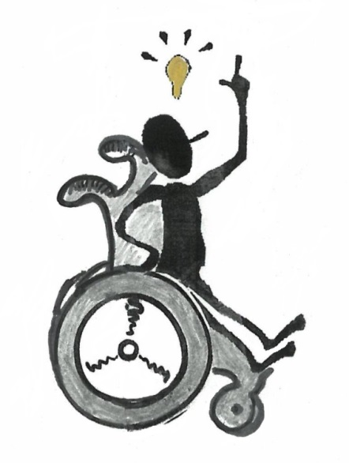

We have tried to make sure that within our discussions the words we use are clear to all team members, including those who may struggle with large words or complicated ideas. This is how we’ve tried to write our charter too.

Our first goal is to make this charter easy to understand.

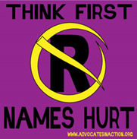Secondly, we needed to make it respectful, even though we know that some of the best words we can find are still a compromise. As of this moment, I/DD seems to be the most respectful term that is used to describe people with varying intellectual and developmental abilities. Indeed, there is a wide diversity in the skills and abilities of people who fall under this label. For instance, some people have physical or cognitive challenges[7]*, or they struggle with time or reading; some people struggle with sight and processing, while some are challenged by large words or ideas. Often, people need support in areas of their daily lives in order to function well in the world. This varies widely, with some people having guardians or requiring a lot of support all or part of the time, and some people only needing support with reading, writing or transportation. You get the Nothing about us without us

Drawn person using a wheelchair and a chain that goes from one arm to the other being broken.idea now.

Poster saying The “R” word:  New and Improved! It’s called Respect

So our forward has to acknowledge that no matter how hard we work at making this charter accessible it may still not be for everyone. It may not feel respectful to everybody. No matter what pictures we choose to try to help with non-verbal ways to tell our story, it may not be clear or helpful to all. It may in fact be triggering[8]* to some people when the hope was to make it better and clearer. So we need a forward to apologize for not having the best words or the best pictures that will make it work for everyone. This highlights why we need a forward. We know that no matter what challenges people may face, they also add to the rich diversity of our communities with their own individual gifts and abilities! We are trying to honor that diversity with how we present our charter and our work throughout the project.

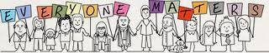

In this charter we are going to talk more about the incredible needs and challenges faced by people with I/DD and how we need to help any survivor of sexual violence[9]* **know they are not alone**; that there is accessible help, safety[10]*, and unconditional support. We want to show survivors how to get help, and how those closest to them can be their allies in the effort to stop further violence from happening. What we hope no one will argue (if they do they are misinformed) is that this particular group has experienced a horrifying amount of sexual violence and very few people will talk about it. We as a new collaboration are going to talk about it, and we're going to do something about it.

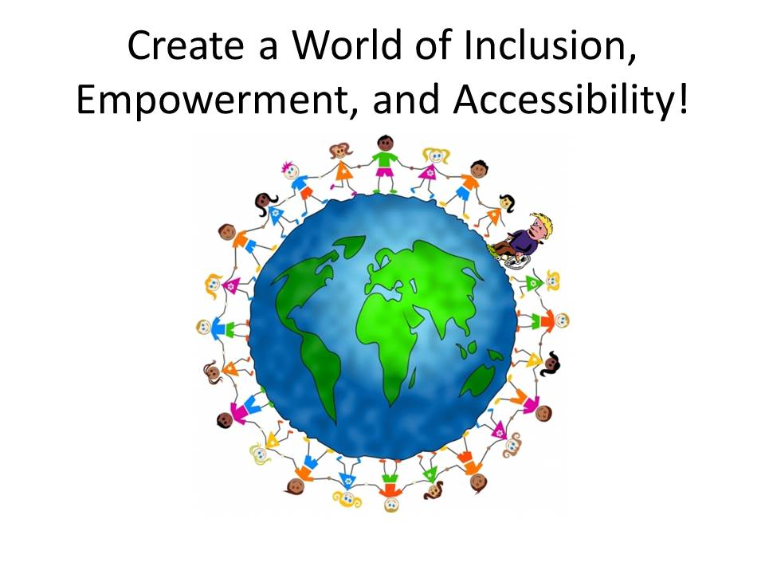

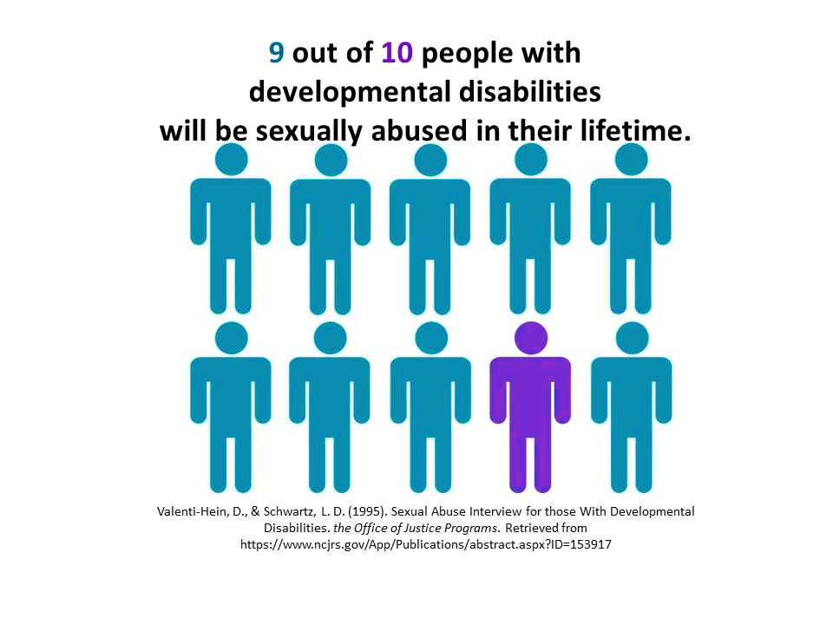**Introduction**

***Why We are Doing This***

People with intellectual and developmental disabilities (I/DD) are at very high risk for sexual violence (i). In 2015, the Massachusetts Department of Public Health (MDPH) found that high rates of sexual violence happen to people with cognitive disabilities (ii). Some national studies are even more frightening. In one study, it was found that more than 90% of people with I/DD will experience sexual abuse [also known as sexual violence] at some point in their lives, with 49% suffering 10 or more experiences of abuse (iii).

People with I/DD are at higher risk for sexual violence because they:

* may rely on caregivers for help with their daily living, like bathing, dressing and personal hygiene
* do not always get sexual education and so are less able to understand that the abusers behavior is wrong or that what is happening is abuse (iv)
* are sometimes thought of (by their caretakers such as parents, guardians and other caregivers) as unable to have healthy relationships that also includes healthy sexuality
* are often not believed when they speak up when sexual violence happens

Survivors with I/DD face added barriers when they speak up about sexual violence and when asking for help. Mass Advocates Standing Strong’s (MASS) Self-Advocates[11]* have often heard from survivors of sexual violence about the barriers they face when looking for help.

Some examples are:

* Fear of speaking up because:
  + 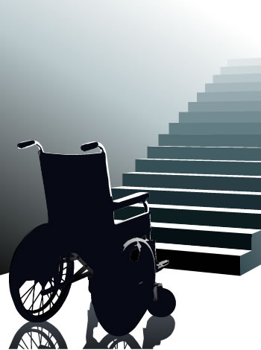“I don’t want to lose my support person.”
  + “I don’t want to be moved into another program/place/home.”
  + they feel they may be hurt even more if they tell
* Little sex education provided, which can lead to:
  + “I didn’t know what happened to me was wrong.”
  + Not being able to describe what happened clearly because the person did not know the proper body part names
  + Feeling shame about one’s body
* Not knowing how to report sexual violence and where to get help.
* 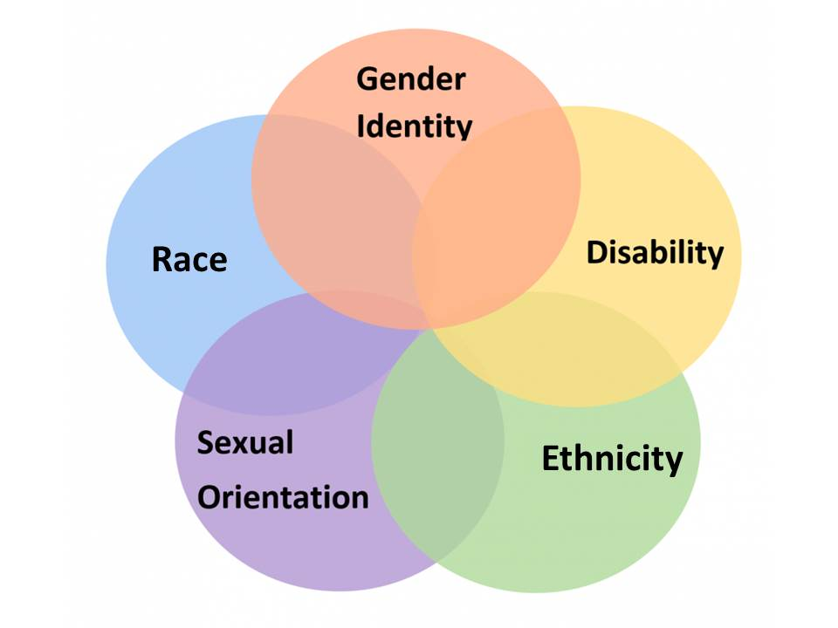Support people (parents, guardians and other caregivers) tell the survivor to “just get over it”
* A person with I/DD who is also part of another protected group often has even more barriers. Race, sexuality, gender, etc. may make them even more vulnerable because of racism, homophobia, sexism, etc. Some other added issues are:
  + Someone in the LGBTQI+[12]* community may not be “out” and disclosing could force them to be “out” before they are ready
  + Believing the experience of sexual violence “made them gay”
  + Not understanding one’s own sexuality/gender

There are additional challenges that occur after sexual violence that could make getting support even more difficult, which include:

* People who may already be isolated because of their disability, may feel further isolated or suddenly stop their work, day services, and contact with friends and family.
* They may not understand triggers and how to deal with feelings associated with triggering events.
* Support people (parents, guardians and other caregivers), try to protect the survivor by not allowing the survivor to make their own decisions. This takes away a person’s independence and decision-making, interrupting their goals for an independent life.

Given these studies as well as personal stories shared with grant partners, we have come together to identify gaps in services for survivors with I/DD. We will also address and remove the barriers they face in trying to access those services.

**The Collaboration and Its Partners**

***Who we are***

**Mass Rights for Change (MRfC)**

We are 3 agencies:

* **Mass** Advocates Standing Strong (MASS)
* Victim[13]* **Rights** Law Center, (VRLC)
* Pathways **for Change**, Inc. (Pathways)

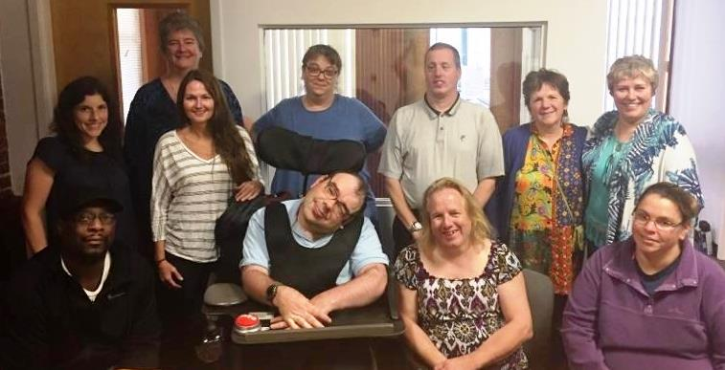

*Back Row*: Kelsey, Inger, Kelly, Heidi Sue, Brian, Susan, Kim

*Front Row*: Shawn, John, Pauline & Pam

We came together to build a collaboration and we have named ourselves Mass Rights for Change (MRfC). We created our name by taking parts of the name of each agency.

***The Individual Agencies***

MASS Logo

Mass Advocates Standing Strong written in the center of an oval surrounded by rainbow colored people holding hand,s some  in wheelchairs and some standing.**Mass Advocates Standing Strong** (MASS) is a grassroots self-advocacy organization run for and by people with intellectual and developmental disabilities across the state of Massachusetts. The partners involved within this collaboration include members from the Central Massachusetts region of MASS. They are also the Awareness and Action team for Central Massachusetts. MASS is the only self-advocacy I/DD organization dedicated to providing peer-to-peer education around abuse and violence in Worcester County. Through its Awareness and Action[14]* Program, MASS’ self-advocates train others in Worcester County about how to recognize, report, and respond to abuse.

***MASS Team Includes:***

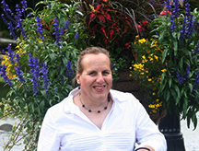**Pauline Bosma**

[rainbowbos@charter.net](mailto:rainbowbos@charter.net); 508-944-5797

Pauline has been with MASS for 18 years. Pauline is founder and Project Director of Rainbow Support Groups of Massachusetts which celebrates 15 years in 2019! Pauline is committed to improving the lives of people who identify as LGBTQI+. She wants to bring sexuality issues out in the open so people can be supported to express who they are. Pauline is skilled at offering a variety of trainings and technical support.

**Picture of John

Photo of man smiling giving a thumbs up sign.John Mullaly**

[johnmullaly97@yahoo.com](mailto:johnmullaly97@yahoo.com);

John has been an Awareness and Action Trainer with MASS for 4 years. He also trains Central Residential staff and third year medical students at UMASS Medical School. John is a certified yoga instructor and reminds participants in abuse trainings to breathe. John says if you can breathe, you can report abuse, and we will believe you! John loves spending time with family and friends. He is a strong advocate[15]* who was raised to think of others first.

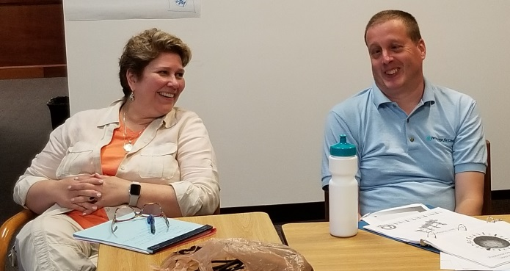**Brian Kelly**

[bkelly1026@icloud.com](mailto:bkelly1026@icloud.com); 508-440-9204

Brian has been with MASS for many years, was one of the creators and has been a trainer of the Awareness and Action Project for over 10 years. Brian is a strong self-advocate and a leader with others. He is passionate about “people first”. He is an active member of the Central Mass Regional self-advocates and Vice President of his local Blackstone Valley self-advocacy group. Brian is on the Disabled Persons Protection Commission Advisory Committee and a survivor of sexual abuse. Brian and his wife Julie married in August of 2018.

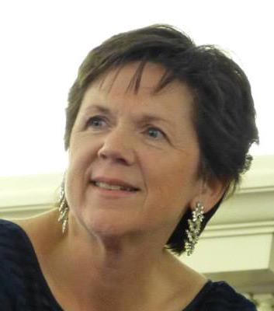**Susan Moriarty**

[Sue@ma-advocates.org](mailto:Sue@ma-advocates.org);

Susan has been with MASS for 7 years, serving as the Central Region Self-Advocacy Coordinator and Awareness and Action Team Coordinator. Sue has a strong background in human rights work. She is passionate about helping people find their strengths and their voices, as well as to remember the importance of each team member.

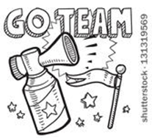

**Support Staff**

The collaboration wants to make sure we acknowledge the support people who are helping throughout this project. We would name each of them by name here, but they may change over time. So we agreed that we would thank them all as a group and that they are valued members of our team. This is to thank all of the support people who are working hard to make sure everyone has what they need to do their best work on this project.

Victim Rights Law Center Logo

Victim Rights Law Center written in white on a teal background with a seedling growing from the word victim.**Victim Rights Law Center** (VRLC) provides free legal services to sexual violence victims in Massachusetts. VRLC is the only organization to offer sexual assault-specific legal services in Worcester County. VRLC offers survivor-centered* and empowering legal representation. VRLC represents all rape and sexual assault survivors in Massachusetts. This includes adults and children; people of all abilities, gender identities, and sexual orientations and immigrants, refugees, and undocumented persons, regardless of immigration status.

VRLC provides legal help on issues such as

* Privacy (for example: protecting private medical and mental health records)
* Disability (for example: help with government benefits)
* Immigration (supporting immigrant survivors with legal issues)
* Victim compensation (money for some of the costs that come from sexual violence)
* Education (for example: helping students with disabilities get accommodations in school)
* Employment rights (example: helping a survivor safely stay or leave their job)
* Housing (for example: helping a survivor safely stay or leave their apartment)
* Safety (for example: protection[16]* orders from the court)
* Supporting survivors within day programs and other disability programs

***VRLC Team Includes:***

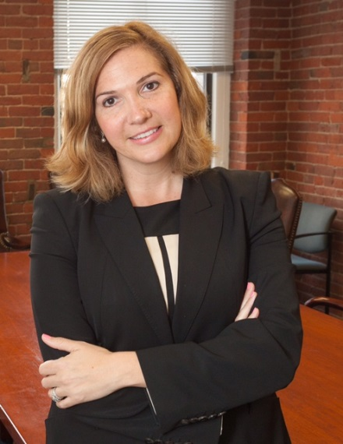**Stacy Malone, Esq.**

[smalone@victimrights.org](mailto:smalone@victimrights.org); 617-399-6720 x 20

Stacy first joined the VRLC as a volunteer attorney in 2004, providing legal representation to sexual assault survivors. She became the Executive Director of the VRLC in 2010. She is passionate about serving survivors and an expert in addressing their legal needs**.**

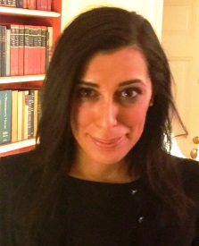**Eleni Kalmoukos, Esq.**

[ekalmoukos@victimrights.org](mailto:ekalmoukos@victimrights.org); 617-399-6720 x22

Eleni is the Managing Attorney of the Victim Rights Law Center. She joined the VRLC in 2015. She supervises all of the VRLC’s legal representation of survivors. She has spent her career serving vulnerable individuals and has experience representing survivors in the areas of safety, privacy, housing, public benefits, and education.

**Picture of Kelsey

Picture of woman workingKelsey Worline, Esq.**

[kworline@victimrights.org](mailto:kworline@victimrights.org); 617-399-6720 x17

Kelsey is a Staff Attorney with the Victim Rights Law Center. She joined the VRLC in 2013. She supervises the VRLC Western Massachusetts office, which serves Worcester County. She also provides representation to survivors throughout Massachusetts in the areas of privacy, safety, education, and housing.

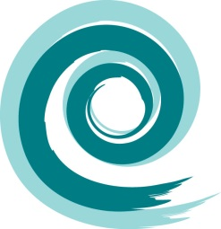**Pathways for Change, Inc.** (Pathways) is a stand-alone multicultural rape crisis center* (RCC). Est. in 1973 and incorporated in 1981. Pathways provides trauma[17]* informed[18]* support services to survivors of sexual violence in ASL, English, Portuguese, Spanish and Vietnamese. Pathways is well-known for innovative work that includes their Deaf Survivors Program (DSP), creation of a hotline collaboration, work with sexually exploited[19]* individuals, Sexual Assault Youth Education (SAYE) program and more. Pathways provides free and confidential support services to 47 cities and towns across Central Massachusetts, that include:

* 24-hour crisis intervention
* Support Counseling
* Healing Circles (support groups)
* Advocacy[20]* in the medical, police and legal settings
* Prevention education for youth and adults
* Professional training
* Community outreach

***Pathways team Includes:***

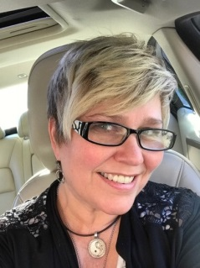**Kim Dawkins,** Executive Director

Contact Information: [KDawkins@PathwaysforChange.help](mailto:KDawkins@PathwaysforChange.help);

508-852-7600 x110

Kim joined Pathways for Change, Inc. in 2005 and has over 25 years of experience in non-profit leadership with an active commitment to social change. Kim has a passion for raising public awareness of sexual violence and its impact within our communities along with a strong belief in developing innovative programs that increase accessibility[21]* to services for ALL those impacted by sexual violence.

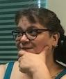**Heidi Sue LeBoeuf, LCSW**, Counseling Director

Contact Information: [HLeBoeuf@PathwaysforChange.help](mailto:HLeBoeuf@PathwaysforChange.help);

508-852-7600 x117

Heidi Sue has worked in the sexual violence field for over 20 years and has been with Pathways since 2000. In 2006 she became the Counseling Director. She has seen the agency evolve over the years and is proud to take part in such endeavors as creating the first hotline collaboration in Massachusetts, working with individuals who have been sexually trafficked[22]* as well as working with the IDD community.

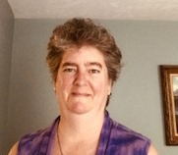**Inger K. Riley, Psy, D.**

Contact Information: [Thrive@IngerRiley.com](mailto:Thrive@IngerRiley.com) (508) 498-0337

Inger Riley has worked in the field of victim services for over 25 years. She has specialized in the field of trauma, and has worked with people with disabilities and those who are Deaf and Hard of Hearing. She is the Project Director for this project and hopes to support all members of the collaboration to do their best work, together, to serve survivors of sexual violence who have intellectual and/or developmental disabilities.

***History of the Collaboration***

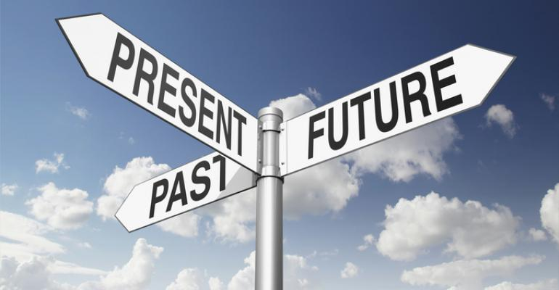In 2007 a program called *Building Partnerships for the Protection of Individuals with Disabilities Initiative*, funded by the Office for Victims of Crime, invited MASS (and others)to begin work on an exciting project that would create a program to educate people with disabilities by trainers with disabilities to *recognize, report* and *respond* to all types of abuse. This is how the Awareness and Action (A&A) trainings began. (See appendix A for more info).

VRLC and Pathways began working together in 2009. Pathways and VRLC’s long standing collaborative relationship includes cross referrals for sexual violence survivors in Central Massachusetts. In addition to referrals, VRLC attorneys provide training to Pathways staff and volunteers to help improve free legal assistance access to sexual assault survivors in Central MA.

Seeing the need and an opportunity to expand services to survivors with I/DD, Pathways forged a connection between MASS and VRLC and agreed to request the funds to support this collaboration. In 2017 we gratefully received grant funding for this project.

**Collaboration Plan**

*What we are going to do*:

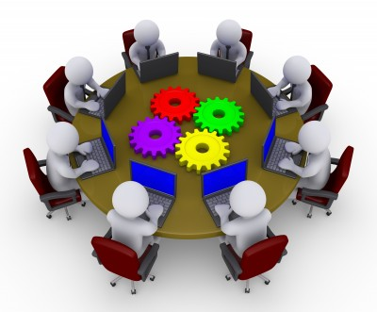

The Mass Rights for Change team is committed to a survivor-centered[23]* approach that empowers individuals with I/DD in Central Massachusetts who have experienced sexual violence. The rest of the charter breaks down our process and exactly what we will do. The main themes are to:

* Create focus groups of clients and staff to identify barriers to services for survivors with I/DD
* Create and conduct assessments of each program and how each can be improved
* Use the information from the focus groups and the rest of the needs assessment to make changes within our agencies to remove barriers to services for survivors with I/DD
* This includes improving access to free services, increasing safety for survivors, and other improvements that come from our needs assessment
* Pathways and VRLC will expand their partnership and include MASS in it
* Create strong and lasting working relationships between MASS, Pathways and VRLC which includes identifying a way to ensure we continue doing this work after the OVW grant cycle ends

**Vision:**

**Picture of a vision

Hand holding a monocle magnifying the details of a landscape way off in the distance**We are all committed to making sure survivors of sexual violence who have I/DD get the support they need. We want to decrease if not stop sexual violence against people with I/DD.

The vision of Mass Rights for Change is to see a future that supports all victims of sexual violence who have I/DD to:

* Recognize they have been abused
* Know they have rights
* Be able to get the services they need without barriers
* Act on their power to manage their recovery and healing
* Have all the help they need to recover in their own way that works best for them

This vision will support all survivors of sexual violence who have I/DD to have doors opened. We will start with our 3 agencies and then we hope to do this across our area, our state, and hopefully the country.

**Mission:**

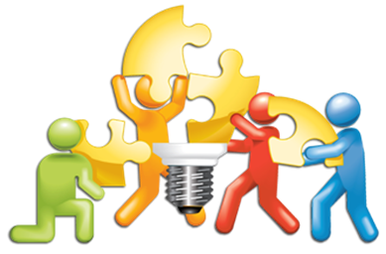The mission of the MRfC team is to remove barriers and increase the services, access and support for survivors of sexual violence who have I/DD in Central Massachusetts. MASS, VRLC, and Pathways will work together to make this change happen by building a strong, on-going partnership, between the 3 agencies. We will do this through respect, team work, true listening and understanding. Specifically we will:

* Develop new ideas that will build trust for survivors of SV who have I/DD
* Review, revise, and create policies, and practices within MASS, VRLC, and Pathways
* Create guidelines to increase accessibility and responsiveness
* Develop plan to improve how people are given help and increase safety with kindness and compassion, making sure that all survivors are believed
* Develop and provide training for the MRfC partners

**Values**

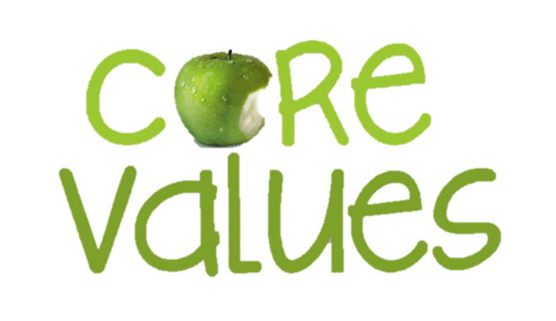 “We are all people first, and we can speak for ourselves” comes from the self-advocacy movement. This statement is important because it focuses on people being in charge of their own lives. In the I/DD community sometimes this is a big challenge because so many people may be involved in a person’s daily life. The MRfC team strongly agrees that the survivor should be in charge of if, when, and how they get support and services. The main values of our collaboration are:

* Understand the survivor comes first
* Treat survivors with respect
* Believe survivors
* Truly listen
* Be accessible
* Support empowerment[24]* by supporting survivor’s rights
* Understand all survivors deserve support
* Understand that safety is essential
* Always provide person-centered services

The core of this collaboration is that it values the whole person seeking help, services, support and safety. We see the person before we see the disability or victim.

**Assumptions**

We believe the following are true based on research, personal stories of others and our own professional and personal experiences. These assumptions will influence, affect, and guide our work together to support people with intellectual and/or developmental disabilities and who experience sexual violence.

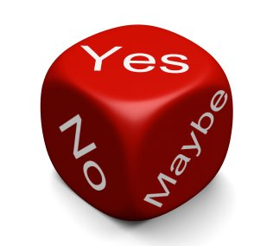

* All survivors of sexual violence have the right to safe and accessible support, care and services that meet their needs
* People with I/DD need access to sexual assault services just as much, if not more so, than the general population
* People with I/DD are hurt by trauma just as everyone else is (v)
* The serious health risks that come with trauma can be worse for people with I/DD because of barriers to getting help (vi)
* People with I/DD can get help from counseling just like everyone else (vii)
* Although it may take longer for people with I/DD to move towards healing, those changes are stable once made (viii)
* People with I/DD who receive services from a rape crisis center are more likely to heal sooner than those who do not (ix)
* Even when the crime is reported, people with I/DD do not usually get help and services as much as many others. (x)

**We Believe**…

* Vision of beliefs

  Quote of Gandhi says "Your beliefs become your thoughts, your thoughts become your words, your words become your actions, your actions become your habits, your habits become your values, your values become your destiny."Every survivor should have access to culturally appropriate and fully accessible services
* Communities should be actively engaged in prevention
* Systems should be well coordinated and survivor-centered with a person first approach
* Survivors should lead all aspects of the community response to sexual violence, especially for people with I/DD

All survivors need their thoughts, feelings, and experiencesvalidated. This means that when survivors share their stories they should be listened to with respect and believed. This sometimes does not happen in general, but seems more so for people with I/DD. Survivors have the right to make decisions about their own bodies and since many with I/DD have other people involved daily with their bodies, this is sometimes even more important for them.

**Agreements/What We Promise to Do**

Shaking Hands

Drawn hands of different skin tones shaking.All of us understand that for this project to work well we need to agree to dedicate ourselves and our agencies to this collaboration. In order to show our dedication we made some agreements together. In our communication plan we describe in detail how we will work together as a team. In this section we want to make sure that each agency and every member are clear about what they are going to do and be responsible for, throughout the project.

All 3 member agencies have agreed to provide the specific people named above to support the project, or replacements as needed. The individual members within the collaboration will work together to identify ways in which survivors of sexual violence who have I/DD will be better served and supported within their own agencies.

**As Lead Agency:**

Pathways is the lead agency and is the main point of contact between OVW and the Mass Rights for Change team. Pathways is also responsible for:

* Managing the grant contract
* Meeting the contract requirements and conditions
* Providing office space and supplies for the Project Director and for the OVW team meetings
* Identifying technology needs for team members, so that all team members can fully participate
* Making sure resources, publications and policies created by the team include the mission and vision of the MRfC team as well as meeting the needs of survivors with I/DD

**Each Agency Agreement**

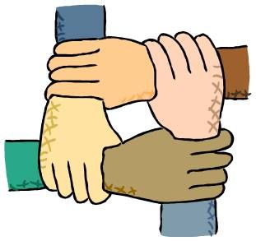

MASS agrees to educate and share information about people who have I/DD. MASS will also provide feedback for plain language[25]* and accessibility issues throughout the project.

VRLC agrees to educate and share information on the legal rights of survivors of sexual violence. VRLC will guide and assist changes to policies, procedures, protocols and actions that support survivors.

Pathways, as the experts on sexual violence issues; agrees to educate and share information about healing, recovery, safety, rights and best trauma-informed[26]* practices for working with survivors of sexual violence.

**All Three Agencies Agree to:**

* 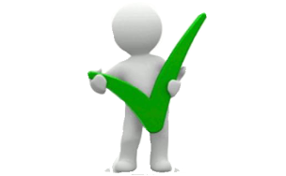Follow all the grant requirements
* Support members to access the Technical Assistance given by Vera including webinars, site visits, and conference calls
* Dedicate time to work on the project and include updates to staff and/or boards within each agency about our progress
* Conduct a Needs Assessment of its agency and create plans to meet the identified needs
* Evaluate our own and each other’s policies, procedures and overall agency culture
* Identify staff to participate in focus groups and indicators[27]*
* Conduct Indicator Scoring Tool assessments if available and host focus groups for clients and staff
* Increase our own organization’s capacity to provide safe, accessible and survivor-centered services to people with I/DD who are survivors of sexual violence
* Plan and then put into action changes in agencies’ policies and procedures to best meet the goals of the Collaboration recognizing that some of these changes may have costs

**Individual Members**

* 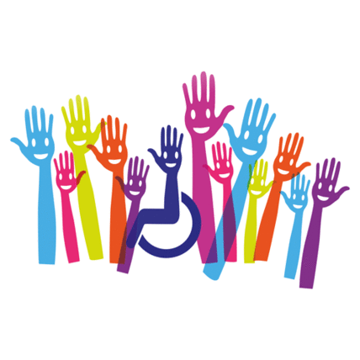Agree to follow the rules of communication
* Attend planning meetings or let people know when you will not be able to attend
* Actively work on all parts of the collaboration
* Follow the guidelines of the grant
* Participate in technical assistance meetings with the Vera liaison
* Participate in webinars provided by Vera
* Attend in-person events

**Communication Plan**

Group Discussion

Diverse group of hand drawn people, one in a wheelchair, around a table with papers and cups  having a discussion.Communication for this collaboration was a topic that we spent a lot of time talking about. This discussion, and the issues that came up, led our plan.

We had to make sure that we could all be reached by phone and by email. This has been an issue for both communication and access to all of our documents and scheduling.

Accessibility for all members is the priority for us. We needed to decide how we would meet, how often, how to make sure no one would be unable to meet due to access, and how we would communicate about all of this. This is what we decided:

* We will meet on the 2nd and 4th Thursday of every month
* If a date does not work for the entire team, a new date will be chosen
* We will meet for 2 hours together in a wheelchair accessible meeting space for our “planning meetings”
* We will then have a ½ hour after our meeting to debrief if necessary, and all are welcome to stay
* Add more meetings in order to go over material, provide access and assistance as necessary, and work on smaller projects that do not require the full team

Between meetings members will communicate by email and/or by phone. This will allow for work on documents, and discussions about topics between planning meetings. Major decisions will be made in person at the planning meetings. No major decisions will be made without the full team’s agreement.

Some decisions can be made between planning meetings regarding scheduling for example, or planning activities, and can be made by email or phone, however it works best for those involved.

Link in the chain

Person as a link in a chain using their arms through chain links to keep it connected.

**Cancellations**

Due to weather or other issues, cancellation of in-person planning meetings may occur. We have worked out a phone and email chain starting with the agency that decides about transportation for two of our members. If they are unable to come, then we will not have our in-person planning meeting. If we have to cancel due to safety issues, or accessibility issues, we will try to meet by phone or on the internet. We will make every effort to be sure at least one member from each partner agency can come to every planning meeting.

**Within the Meetings**

MRfC has agreed on how the team will communicate within meetings to make sure everyone has a voice and can be heard at the table.

We will use the following:

* Respect
* Plain Language
* Raise your hand or press a buzzer and be called on before you start to speak
* Agree to pay attention to others who have their hand raised or pressed the buzzer, to make sure everyone has an opportunity to share
* Stop the conversation whenever necessary, to clarify or ask a question or in any way re-group before moving on
* Be each other’s allies’ to make sure that when people are waiting to speak, they get their turn

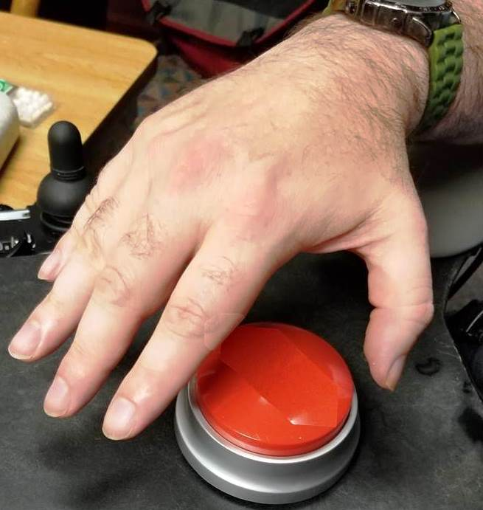We, as a team, have agreed to follow the rules to the best of our ability. We have a buzzer for a member of the team to “ring in” when he has something to say as raising a hand or speaking up in real time is challenging. In order to make it easy for all members to be called on when wanting to add to conversations, this button was added to the communication plan.

We understand that even when everyone is paying attention, sometimes communicating will be challenging. So we also have agreed that:

* Our meeting space is safe enough to ask any question
* We can try out new language or concepts without fear of judgement
* Any one of us can request further help, support, clarification on any area that the team is working on

**The Team and the Vera Institute**

* The Project Director will be the main contact between the collaboration and the Vera Institute
* The Project Director will talk by phone, bi-monthly for one hour with a Vera representative, and more as needed, for technical assistance
* The Project Director will keep the team up to date about the conversations with Vera
* Any member of the team can request technical assistance from Vera
* All members will have some contact with our technical assistant at Vera through site visits and conference calls

**The Team and OVW**

* The Director of Operations of Pathways and the Project Director will be the main contacts for OVW
* The team will be kept informed about any information from OVW
* Any member can have contact with OVW

**Spreading the Word/Media**

Press conference microphones.  

Many microphones ready to record someone talking at a press conference.The team has discussed that many people will be interested in what we are doing within this collaboration. We have agreed that we want people to learn that sexual violence for people with I/DD is real and happens a lot. We also want people to know that we three agencies are working together to try to help those survivors and to stop abuse from happening.

We have agreed that when people ask us or want to know about our work on the grant we will tell them:

* The grant was paid for by OVW
* OVW is the Office on Violence Against Women
* The names of the agencies in the collaboration
* The partnership is to look at our agencies and create plans to make us more accessible and welcoming for survivors with I/DD

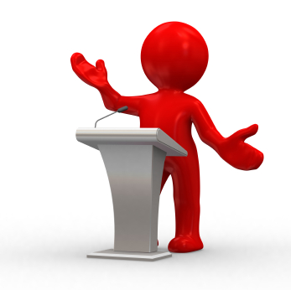We have created a handout that members can give or read to people to explain our collaboration. (See Appendix B)

We will discuss with staff and others within each agency how our collaboration is moving forward, as we continue with our work. We will make sure we tell people what we are doing and how each agency will be getting better in providing services and support to survivors with I/DD as we proceed.

Media sources (such as TV, print and online news, radio, etc.) may ask for information. Our team has agreed that before anyone responds, approval by all team members is needed. For requests needing an answer right away, we will use our communication plan (see pg. 26) to contact the team for quick approval.

As for social media, the team needs to agree on any postings/sharing/distribution of information about MRfC. This includes across our personal or our agencies’ social media platforms.

**Privacy**

Privacy is a very complicated issue for people with I/DD. Our team spent a lot of time talking about this issue to make sure we understood it from the many viewpoints shared. Since people sometimes give up some of their privacy to be aided and supported, we had to look at the idea of privacy, as an issue in the community, and also how we as a team would work with privacy.

The hope is that people who are allowed to be aides and supports to people with I/DD are trustworthy. People who provide support may have access to an individual’s private information, to a person’s body, or to their most private relationships. A person may need the help, so they try to trust that an aide or support person will be respectful and trustworthy. This is especially true for people needing help with their bodies, or access to personal letters, emails, phone calls, notes, medical appointments, connections with family, and so on.

The most important part about privacy is who is in control of it. This can be complicated with guardians and others who may be involved in the life of a person with I/DD. Therefore, this is even more sensitive when talking about sexual violence, and how to support a survivor’s privacy. For many survivors, taking back control when they have been victimized, sometimes starts with their “survivor story”, and how they tell what happened to them.

Privacy can be even more complicated because a survivor’s body can have evidence on it, in it, and pictures of it. How we help survivors of sexual violence to control all of their information (stories, evidence, photos), and who may also be legally involved with making choices and decisions, are all connected to privacy. Therefore, privacy needed to be fully discussed to be clear about how to protect people’s privacy, support the most empowerment possible, and protect people’s rights.

While discussing privacy, the issue of confidentiality also became another word and idea that our team needed to discuss and understand. One thing we discussed was that this is a legal issue, for mandated reporters.

All members from Pathways and MASS are mandated reporters[28]*, which means that they are required to report active abuse of a person with a disability, if done by a caretaker. They are required to report this abuse to the Disabled Persons Protection Commission (DPPC), the state protective service agency for disabled persons. Since the VRLC members are all lawyers, they are required by law to protect the privacy of their clients.

The second issue about confidentiality is making sure we are clear with everybody about when someone is a mandated reporter and can’t keep information confidential. We agreed to include paperwork within our needs assessment and any work we do, that is very clear about these limits. Also any information that the collaboration collects will need to be anonymous, so that people can feel free to give their true answers without worrying about hurting someone’s feelings or not getting good services, or getting in trouble at work or in the community.

To do this we have agreed to make sure

* Privacy of all survivors will be maintained unless a reportable issue becomes known
* All paperwork and information in writing or read out loud will be in plain language and people will have chances to ask more questions before going forward with any group or interview
* Information shared between members about ourselves will be kept private
* If discussing a survivor MRfC members will not use identifying information, which would be ways to know who the person is even if you don’t use their name, or their address for example
* Any information collected will be kept confidential by not using identifying information
* All members will follow their agency rules as well as legal and ethical rules regarding working with survivors of sexual violence

**Decision-Making**

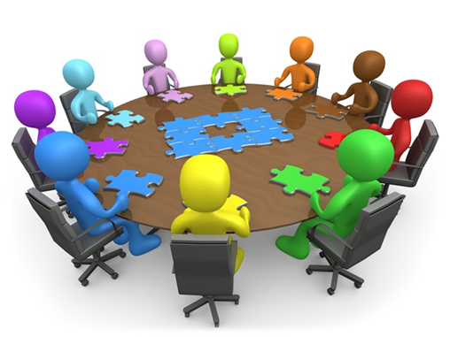

All team members will be involved with making decisions. Often people with I/DD are not actively asked for their opinions and thoughts about subjects. Because of this we, as a collaboration, are very sensitive about communicating with each other and coming to decisions that we are all comfortable with. The way we will make decisions was fully discussed by the team. We talked about the many ways to come to an agreement, and we decided on consensus.

Together we agreed this would work best for the team. The discussion that really helped us make this decision was based on the belief that consensus requires compromise and working as a team to reach decisions. We understand that we won’t always agree on everything, but we have committed to listening to all viewpoints with respect and an open mind. Then we will carefully come to consensus as a group, which will reflect our common values and shared goals of the project.

Decision Making

Drawn road with a "Yes/No" sign at the fork.In order to make sure that all members are heard, each member will be asked to share their thoughts or input on a particular decision that is being made. Once all have shared their opinion, a consensus can be built on the input. When we believe we all agree, we will ask each person again, to be sure everyone’s thoughts have been shared. We will then ask one more time, if all agree, and then the team can move forward.

Thumbs down from the team

3 pictures all of people with disabilities giving a thumbs down.**What to Do When We Disagree:**

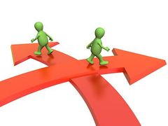When we cannot agree on something, we will first take turns at voicing our thoughts. When we do this, we will provide information as to why we disagree or feel a certain way. If disagreements cannot be worked through, the team has agreed to take the steps below to come to an agreement:

* First understand disagreements are okay and that we know we won’t always agree on everything
* Understand working through disagreements can make things better by working together on a solution
* Work at understanding what each of our point of views are
* Listen with an open mind and without judgment
* Compromise: Work together to find a resolution that we all can agree on and at least be "okay” with the decision

If the disagreement cannot be resolved in this way, one chosen member from each agency along with the Project Director will try to come to an agreement together. This agreement will then be brought to the entire team to decide. If this does not resolve the issue, then the issue will be discussed with the Vera Institute of Justice liaison for assistance. If all of the above do not resolve the issue, Vera and OVW will be contacted for more help in resolving the issue.

John giving a thumbs up

John in his wheelchair smiling, giving a thumbs up.

**Work Plan**

|  |  |
| --- | --- |
| Collaboration Charter | Complete September 2018 |
| Approval by OVW | October 2018 |
| Statement of Focus & Approval by OVW | October/November 2018 |
| Develop Needs Assessment Plan | November & December 2018 |
| Approval by OVW | January 2019 |
| Conduct Needs Assessment | February & March 2019 |
| Develop Findings Report | April & May 2019 |
| Approval by OVW | June 2019 |
| Develop Strategic Plan | July & August 2019 |
| Approval by OVW | September 2019 |
| Implementation | October 2019 – October 2020 |



**Glossary**

|  |  |
| --- | --- |
| **Accessibility:** | When something, someplace or someone is reachable, attainable, and easy to understand (as in written materials), easy to enter (as in a building), easy to use (as in equipment) |
| **Action and Awareness:** | A project of the Mass Advocates Standing Strong, this training teaches people with disabilities to recognize, report and respond to abuse |
| **Advocate:** | A person who openly and publicly supports an individual, cause or policy; fights for something such as for a cause of for rights; someone who supports someone or something |
| **Civil legal support:** | Free legal assistance to those in need who have civil legal problems. VRLC helps survivors of sexual violence who have legal issues that are non-criminal. VRLC helps survivors of SV with legal issues in housing, employment, and education after a sexual assault |
| **Cognitive Challenges:** | This is used to describe difficulty in areas of thinking and working through ideas. People with cognitive challenges can have difficulty making sense of certain ideas without a lot of support, or trouble reading or remembering things in the order they happened, etc. |
| **Consent:** | Giving permission for something to happen or an agreement to do something |
| **Disability:** | This can be a legal term that means under the law a person is seen as having challenges that require special accommodations. It can also mean a person who has challenges with their body or with their mind that involve moving, thinking, feeling through senses or emotions that require some accommodations to manage |
| **Empowerment:** | The power someone has within themselves to do something; the process of becoming stronger, more confident and feeling in control over one’s own body, decisions, and being able to ask for help or support when needed |
| **Inclusion:** | Being accepted as part of a larger group and being treated the same as everyone else |
| **Lightbulb over person  Drawn picture of shadow person coming up with an idea represented by a lightbulb turning on over his head.Indicators:** | stack of books  A stack of different colored hardcovered books.Many agencies and groups have created these to better understand how well programs are working and what needs to be improved. There are usually many types of questions that try to help people look at areas that can be improved and be able to measure that improvement by answering the same questions over time. |
| **Intellectual and Developmental Disability:** | According to the American Association on Intellectual and Developmental Disabilities, “intellectual disability is one type of a larger universe of many types of developmental disabilities. Developmental disabilities are defined as severe chronic disabilities that can be cognitive or physical or both. Intellectual disability encompasses the ‘cognitive’ part of this definition that is a disability that is broadly related to thought processes. Because intellectual and other developmental disabilities often co-occur, intellectual disability professionals often work with people who have both types of disabilities” |
| **Intersectionality:** | Overlapping areas where someone might face oppression (example: someone with a disability is a person of color and is lesbian) |
| **LGBTQI+** | Is a shortened way to name communities who identify sexually in a way that is not "straight" (heterosexual) or identify as a gender that was not assigned to them at birth. *The letters mean: Lesbian, Gay, Bisexual, Transgender, Queer or Questioning, and Intersex and '+' for other communities not identified by letter* |
| **Mandated Reporter:** | Someone who has contact with vulnerable people and is legally required to ensure a report is made when abuse is observed, suspected or reported to them |
| **Natural Support:** | Relationships that occur in everyday life, often including family, friends, coworkers, neighbors and even acquaintances; if you are with someone you know who has a disability, you agree to make sure to think about them in an emergency: being an ally for someone who has need for support during certain circumstances |
| **People First Language:** | Words that focus on the person first before the disability |
| **Plain Language:** | Communicating in a way, either in writing or spoken, that makes sure that the information is understandable the first time it is read or heard. There is no jargon or other confusing language, so it can be understood for the group especially those who are using the information |
| **Protection:** | Someone or something that prevents someone from suffering harm or injury |
| **Rape crisis center:** | Community based organizations that are part of the anti-sexual violence movement with the purpose to and who help, support and address the needs of survivors of all forms of sexual violence, including but not limited to: rape, molestation, sexual abuse, incest, verbal sexual harassment and so on |
| **Safety:** | Being protected from danger, harm, risk or injury |
| **Self Determination:** | The process by which a person controls their own life. The National Gateway to Self-determination says it means to make choices and decisions based on a person’s own preferences and interests, to monitor and regulate their own actions and to be goal-oriented and self-directing. |
| **Self-Advocate:** | When someone speaks up for themselves; being assertive; firm; making their own decisions about the future, understanding their own strengths and challenges. |
| **Sexual Exploited** | A form of sexual violence that includes being forced into sex or sexual acts for drugs, food, shelter, protection, other basics of life, money, etc. |
| **Sexual Violence:** | A sexual act committed against another without that persons’ consent; is about the abuse of power and control |
| **Support:** | Giving assistance materially, such as clothing, food, money as well as, emotionally or physically |
| **Survivor:** | More empowering term than ‘victim’; someone who copes with difficulties and/or difficult events in their life; rape crisis centers utilized this term to highlight the strength and courage of those who experience sexual violence |
| **Survivor-Centered** | Applying a human rights approach ensuring that survivors of sexual violence:   * are treated with dignity * are not blamed * has a right to privacy and confidentiality * does not face further discrimination * receives support, information and referrals to expand their support systems |
| **Trauma** | Trauma is an emotional response to a terrible event like an accident, rape or natural disaster. Immediately after the event, shock and denial may happen; reactions over time may include unpredictable emotions, flashbacks, challenges to relationships and even physical symptoms like headaches or nausea |
| **Trigger:** | “Triggers” are people, places, smells, sounds, tastes, or things that remind a person of being hurt and cause them to feel fearful, nervous, or panicked. (For instance, if they were hurt by someone who smelled like smoke or a certain type of cologne, those smells may trigger flashbacks of that event/ assault.) Once triggered, they may feel depressed, angry, or fearful for a period of time |
| **Victim:** | A term often utilized in medical and legal settings; someone who is harmed or injured as a result of sexual violence; often used in place of ‘survivor’ |

Awareness and Action Logo

Red, white and blue logo with 2 A's and Awareness & Action written across the bottom.

**Appendix A**

*More about the Awareness and Action Training*

For over three years, people with disabilities and others worked side by side to create an accessible, three hour training called: “*Awareness and Action: educating persons with disabilities on recognizing, reporting and responding to abuse*”. Five regional Awareness and Action training teams from MASS were created to work within their communities. Since that time, hundreds of trainings have been provided, and thousands of people with I/DD and other disabilities have been educated on *Recognizing, Reporting and Responding* to abuse.

Some key points that guided the project were:

* People with disabilities train people with disabilities and others
* Everyone is invited to attend including care takers, support staff, etc.
* Plain language is used and the training is accessible and interactive visually; includes audio description; and with pictures, in order to meet different learning styles
* People First Language is used
* Confidentiality is essential
* Everyone leaves the workshop with materials that can be used outside the workshop to help them remember how to *recognize, report* and *respond abuse*
* Community resources regarding abuse are provided to each participant.

Three members of the Central A&A team were founding members of the A&A project and are part of the MRfC team.

Appendix B

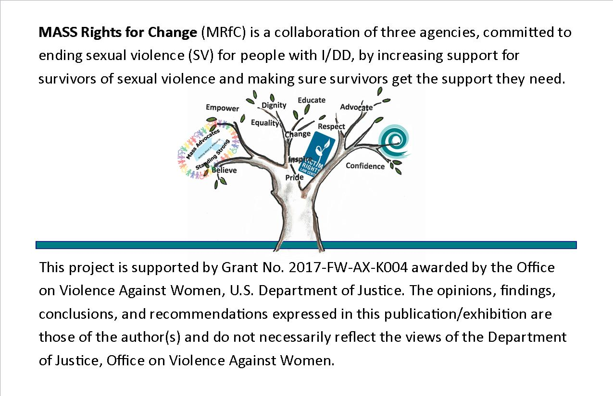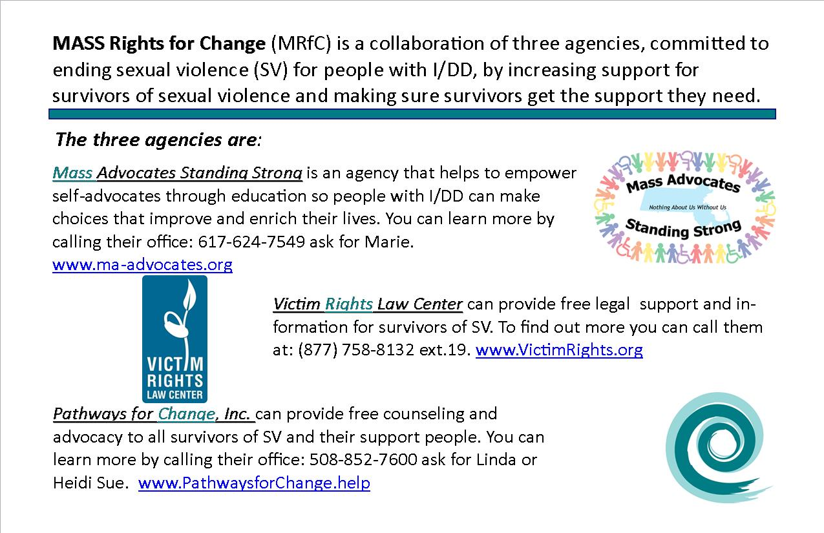**References**

Front

Back

1. Cornell University’s Disability Status Report for Massachusetts (2012). U.S. Census Bureau (2010). U.S. Bureau of Justice (2015). Global meta-analysis shows rates of 2.5 to 11.1 times that of the general population. Karen Hughes et al., Prevalence and risk of violence against adults with disabilities, Lancet (2012). Dick Sobsey, Violence and Abuse in the Lives of People with Disabilities (1994). Valenti-Hein et al., The Sexual Abuse Interview for Those with Disabilities (1995).
2. *SeeTable 2: Prevalence of Sexual Violence Among MA Residents Ages 18+ By Cognitive Impairment, (2013-2015) Massachusetts Department of Public Health, Office of Statistics and Evaluation analysis of CDC 2005 BRFSS data. Harrel, E. (2011). Crimes against persons with disabilities, 2008-2010 statistical tables. US Dept. of Justice. https://www.bjs.gov/content/pub/pdf/capd10st.pdfMA Rehabilitation Commission (2016).* http://www.mass.gov/eohhs/docs/mrc/mrc-disability-fact-sheet-2016.pdf http://www.cdc.gov/brfss/annual_data/annual_2005.htm.
3. Valenti-Hein et al., The Sexual Abuse Interview for Those with Disabilities (1995).
4. Sobsey, supra.
5. Margaret Charlton et al., Facts on Traumatic Stress and Children with I/DD (2004).
6. Id.
7. Sheila Mansell et al., Clinical Findings Among Sexually Abused Children With and Without I/DD (1998).
8. Brian Tallant, Adapted Trauma-Focused Cognitive Behavioral Therapy for Children Who Have Intellectual Disabilities (2010).
9. Id.
10. Nora J. Baladerian et al., Abuse of People with Disabilities (2013).

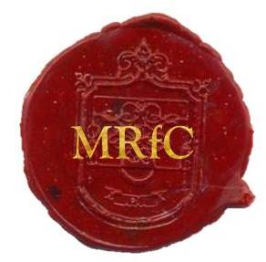

Mass Rights for Change, seal of approval.

1. * See Glossary
2.
3.
4.
5. * See Glossary
6.
7.
8. * See Glossary
9.
10. * See Glossary
11. * See Glossary
12.
13. * See Glossary
14. * See Glossary
15. * See Glossary
16. * See Glossary
17. * See Glossary
18.
19.
20.
21. * See Glossary
22.
23. * See Glossary
24. * See Glossary
25. * See Glossary
26.
27. * See Glossary
28. * See Glossary