Strategic Plan

Empowering people with disabilities
who have experienced
domestic violence and/or sexual assault.

This project is supported by Grant No 2010-FW-AX-K003 awarded by the Office of Violence Against Women, US Department of Justice.
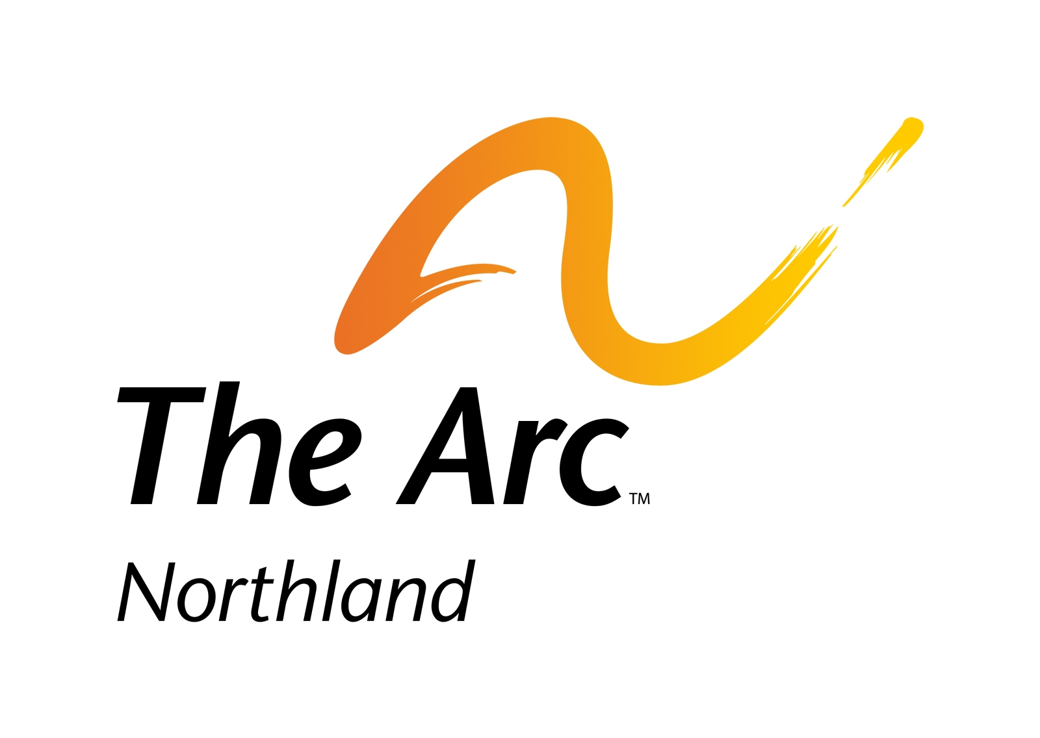
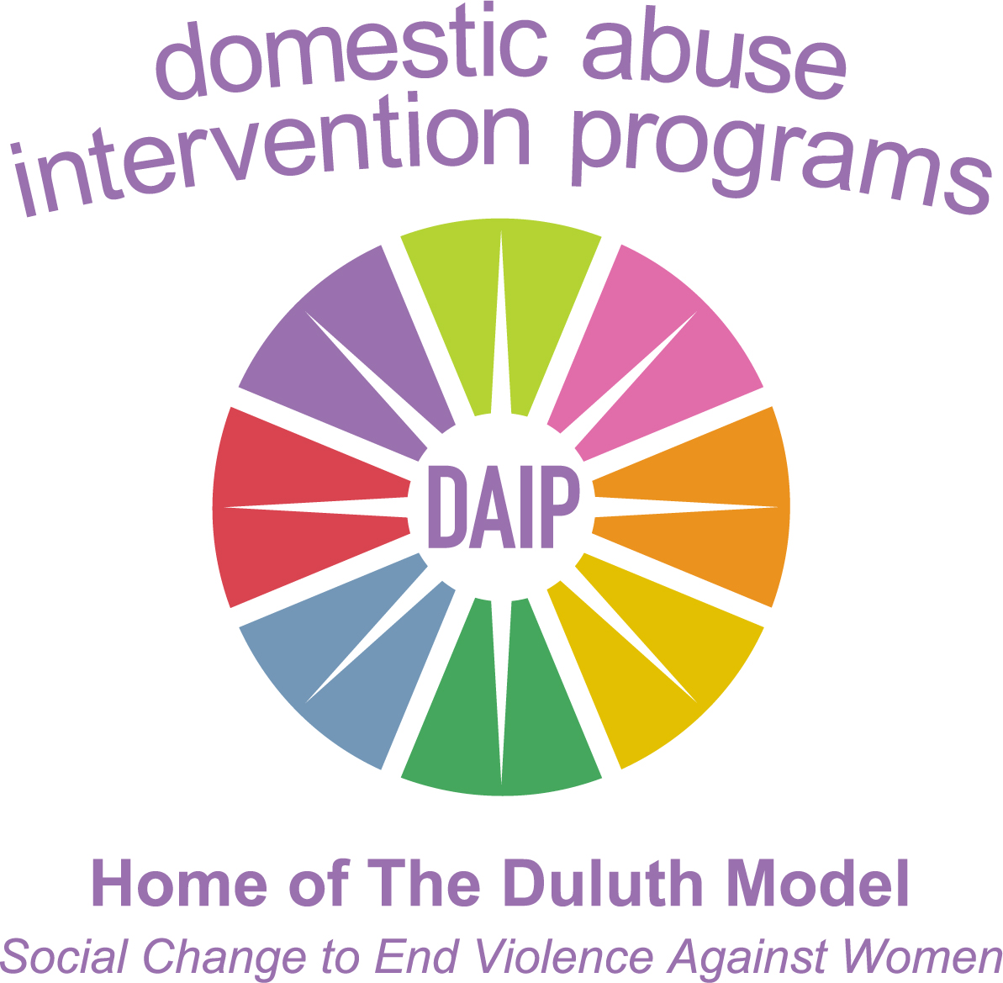
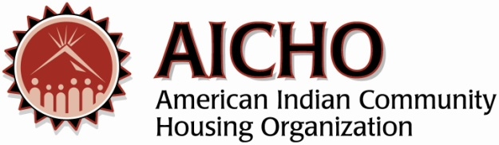

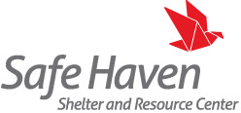
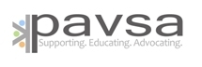
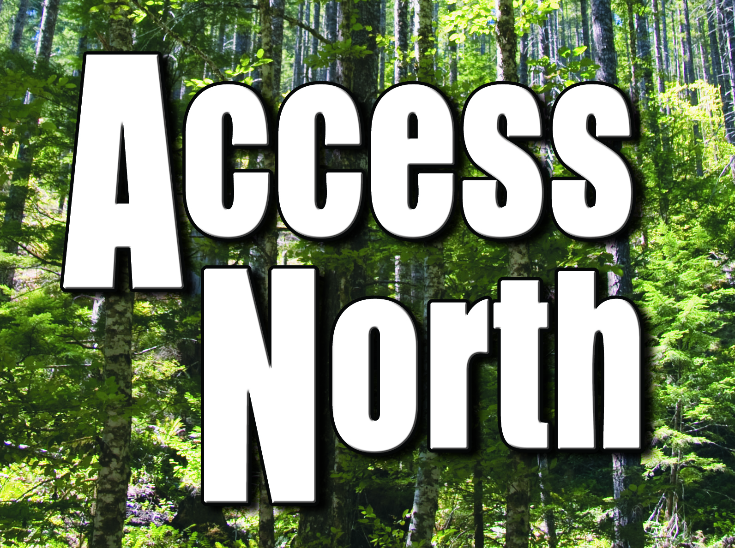

Table of Contents:
I. | Collaboration and Planning Phase Overview | 3
II. | Needs Assessment Plan Summary | 5
III. | Needs Assessment Report/Findings | 8
IV. | Strategic Plan Development Process and Overview | 10
V. | Strategic Plan Initiatives  Initiative 1:  Foster Staff Comfort, Confidence and Abilities  Initiative 2:  Increase Agencies’ Safety, Accessibility & Cultural Competency  Initiative 3:  Evolve and Sustain the Connections Collaboration | 13
VI. | Long Term Initiatives | 19
VII. | Sustainability | 24
VIII. | Conclusion | 24
Appendix:
A | Strategic Plan Initiatives Overview
B | Step-by-step outline of initiative tasks and activities
C | Initiative 1 Timeline
D | Initiative 2 Timeline
E | Initiative 3 Timeline
Section I. Collaboration and Planning Phase Overview

Connections is a collaboration between:
American Indian Community Housing Organization (AICHO)
Access North, Center for Independent Living of NE Minnesota
Arc Northland
Domestic Abuse Intervention Programs (DAIP)
PAVSA (Program for Aid to Victims of Sexual Assault)
Safe Haven Shelter for Battered Women (Safe Haven)

The American Indian Community Housing Organization (AICHO) offers one of only 26 culturally specific domestic violence shelters nationwide, and a variety of programming including supportive housing to families, individuals and youth who have experienced long-term homelessness, transitional housing to survivors of domestic violence, and financial assistance to people in a housing crisis.

Access North, Center for Independent Living of Northeastern MN, provides services to people of all ages with any disability to pursue their goals and have the same choices as all people. We assist with independent living skills, advocacy, peer and group support, and information and referral.

Arc Northland provides advocacy, support and education to people with all disabilities and their families, from birth to end of life.

Domestic Abuse Intervention Programs (DAIP) coordinates the Duluth criminal justice response to domestic violence including a men’s non-violence program, support and education for partners, supervised visits, and exchanges and conducts national trainings based on the domestic violence intervention work we do here in Duluth.

PAVSA (Program for Aid to Victims of Sexual Assault) is dedicated to supporting victims, educating the community, and advocating for change. Our core values include free and accessible victim-centered and victim-driven services. All of our services, including a 24-hour crisis line, hospital advocacy, SANE program, counseling, legal services, and court advocacy are free and confidential for our clients.

Safe Haven Shelter and Resource Center provides comprehensive services to victims of domestic violence including a twenty-four hour crisis line, emergency shelter for battered women and their children, legal advocacy, and education and support groups.

Historically, domestic violence and sexual assault agencies have not been connected with agencies who serve people with disabilities, in our local community. Additional complex barriers exist for a person with a disability and collaboration among agencies is necessary to address these barriers. We acknowledge that this gap in service exists and possess a shared commitment to address the issues at hand. Since 2004, several efforts have been started to address the needs of people with disabilities who have experienced domestic violence and/or sexual assault in the Duluth community. However, due to a lack of dedicated funding, we have been unable to build a consistent level of services and the collaboration has been relatively informal. In the past, we have made small changes, only to lose momentum when staff changed or lack of funding impacted partner agencies. It has been a challenge to create a culture of awareness at the intersection of disability and abuse. These issues are important and necessary to address not only across our country, but specifically here in Duluth, Minnesota. We have developed three initiatives to focus on during implementation. These initiatives were identified from the needs assessment findings.

These six partner agencies are committed to a long-term multi-disciplinary collaboration. Through this collaboration, each of the partner agencies is gaining a greater understanding of the mission, programming, staffing, culture, abilities and limitations of our agencies. This process is assisting us to increase safety and accessibility for people with disabilities who have experienced domestic violence and/or sexual assault.

This three year project, funded by the Office of Violence against Women (OVW), allows our partner agencies to fully commit the time and energy to develop a true collaboration to result in effective, lasting and sustainable change to increase safe accessible services for people with disabilities who have experienced domestic violence and/or sexual assault (DV/SA). Between October 2010 and September 2013 the collaborative will go through two phases.

During the first phase we focused on planning and development; beginning with our collaboration charter. Through our charter process, we developed a shared vision and mission to guide our project over the three year grant project, as we continue to create sustainable change.

Vision: We envision an informed community where people with disabilities who have experienced domestic violence and/or sexual assault are empowered by a system of inclusive, accessible, and self-determined services, resulting in equal access to safety and justice.

The mission of Connections is to join disability, domestic violence, and sexual assault programs to create a seamless approach to providing safe accessible services to people with disabilities. We will:
- Listen to and validate the experiences of people with disabilities.
- Foster relationships among partners and fully utilize their resources and expertise.
- Remove physical, programmatic, communication, and attitudinal barriers to services.
- Enhance and promote safe and responsive services.
- Adopt policies and practices to instill safety and accessibility into each partner agency.
- Increase knowledge of domestic violence, sexual assault, and disability issues and their intersections among staff, people with disabilities, and the community to create long term social change.

II. Needs Assessment Plan Summary

After our charter was completed and approved we began the next step of developing a needs assessment plan with specific goals and tools to gather valuable input from all levels of each partner agency. The following four goals assisted our collaboration to identify what is currently working and what can be improved upon within and among our partner agencies to best serve people with disabilities who have experienced domestic violence and/or sexual assault for long lasting sustainability.

Goal 1: Identify the level of knowledge of each partner agency staff that enhances or limits a safe and supportive environment for people with disabilities who have experienced domestic violence and/or sexual assault.

Goal 2: Identify current agency structures and gaps within partner agencies with regard to policies, procedures, protocols, and trainings that address the needs of people with disabilities who have experienced domestic violence and/or sexual assault.

Goal 3: Identify programmatic, attitudinal, and physical barriers to accessibility, and methods to enhance capacity of each individual agency.

Goal 4: Identify what formal and informal relationships exist between partner agencies, barriers that limit these relationships, and opportunities to grow and sustain the collaboration.

The needs assessment report helped to inform the work of our collaboration by identifying the potential changes to be made within each agency in providing a safer, more accessible, and more welcoming programs for people with disabilities who have experienced domestic violence and/or sexual assault. The needs assessment findings were used to establish initiatives for this strategic plan and helped us to clearly define the tasks and goals that need to be addressed during implementation.

We primarily used focus groups and interviews for our needs assessment process which allowed us to receive a range of diverse perspectives from clients, volunteers, direct service staff, and supervisory staff.

The following chart provides a quick overview of the total number of people who were involved in focus groups or interviews as detailed above.

Focus Groups | Target # participants | Actual # participants
People with Disabilities | 12 to 25 | 12
Survivors of DV | 12 to 25 | 17
Survivors of SA | 6 to 10 | 10
Arc Northland Staff | 3 to 8 | 4
Access North Staff | 3 to 8 | 13
Access North Supervisors | 2 to 4 | 3
AICHO Staff | 3 to 8 | 3
DAIP Staff | 3 to 8 | 5
DAIP Supervisors | 3 to 4 | 3
PAVSA Staff | 3 to 8 | 4
PAVSA SANE | 3 | 6
PAVSA Volunteers | 2 to 5 | 3
Safe Haven Staff | 3 to 8 | 15
Work Group members | 4 | 4
Volunteers SHS/FJC | 1 to 3 | 2
Individual Interviews | Target # interviews | Actual # interviews
Agency Directors | 6 | 6
Supervisory Staff | 2 to 4 | 2
Board Surveys | Target # surveys | Actual # surveys
Access North |  | 3
Arc Northland |  | 3
AICHO |  | 1
DAIP |  | 7
PAVSA |  | 4
Safe Haven |  | 6
 | 45-75 total | 24 total

III. Needs Assessment Report and Findings

Overall our needs assessment process was successful and informative. Many of our assumptions were reaffirmed regarding barriers that all partner agencies face in providing welcoming, safe, and accessible services to people with disabilities who have experienced DV/SA. We also received a variety of suggestions that were considered from survivors, people with disabilities, staff, and volunteers for increasing safety and access that we incorporated into our strategic plan. The feedback we were given was applicable to our needs assessment goals and helped guide our strategic plan. We identified the following key findings that were consistently addressed by a range of participants:

1. Lack of organizational resources. Limited funding and staff and a high number of people in need of services creates a challenge for each partner agency to increase capacity for working with survivors with disabilities.

2. Need for increased awareness and cross training. There is a lack of understanding and knowledge of the unique barriers and support services that exist for people with disabilities and for survivors of DV/SA. Across all partner agencies there is also an identified need for further training regarding cultural competency and sensitivity.

3. Gaps in policies, procedures, practices. Currently there is a lack of clear consistent policies, procedures, and practices that address the importance of identifying and accommodating disability, addressing safety, and handling confidentiality.

4. Need for increased organizational relationships. Although there is a lot of great collaborative work happening between our partner agencies, the majority of staff members at all partner agencies have limited knowledge of each agency’s programs. Another barrier that is crucial to address is the lack of personal connections between partner agency staff members.

5. Vision for sustainability. It has been a challenge to fully address the needs at the intersection of disability and victim services with a lack of staff time, shortage of dedicated funding for direct service, and staff changes. In order to create long lasting change we must work together, capitalize on each other’s strengths and skills, and build upon our existing programs to best serve people with disabilities who have experienced domestic violence and/or sexual assault.

6. Barriers to safety, accessibility, and welcoming environments. It is critical to identify and address barriers that exist so all survivors can safely access our programs. Physical, attitudinal, programmatic, and transportation accessibility must be increased to make our services available to all people with disabilities. In addition, a welcoming environment is a key component to create a seamless approach to provide safe and accessible services.

While identifying these key findings we also were identifying possible solutions to keep in mind for implementation while we began developing this strategic plan.

- Conduct accessibility and safety audits of all partner agencies to identify possible areas to provide more welcoming, safe, and accessible services and look into opportunities to make these changes.

- Address how to incorporate universal design into existing programs and spaces to increase access for the greatest number of people.

- Incorporate ongoing training opportunities for victim service staff to learn more about different types of disabilities and accommodations.

- Incorporate ongoing training opportunities for disability service staff to learn more about responding to disclosures of abuse and safety planning.

- Provide cross training on programs for survivors with disabilities at our partner agencies to all direct service staff. If possible, provide tours of partner agency locations to create greater awareness of the programs.

- Create a list of resources of safe and accessible services for survivors with disabilities to create more appropriate referrals.

- Review existing policies and procedures across partner agencies and consider ways to increase consistency with addressing accommodations, safety, and confidentiality, along with formalizing any informal procedures that create confusion for staff and clients alike.

- Utilize each agency’s specific areas of expertise; incorporating cross-training with other partner agencies is a perfect opportunity to increase staff knowledge of disability and awareness of resources at the intersection of abuse and disability.

- Explore opportunities to provide a more welcoming environment and increase accessibility and safety to our services for all people.
In order to build our collaborative work, we need to recognize and accept the opportunities for change and improvement, and provide staff time and agency resources to create these changes. As we moved into the strategic planning phase, we remained focused on allowing these findings to guide our future work.

IV. Strategic Plan Development Process and Overview

Connections core work group met regularly to debrief after each focus group during the needs assessment. We used this opportunity to identify the key findings and consider possible initiatives as we moved into implementation. As we identified the key findings in our needs assessment report, we took this information along with other feedback we received in focus groups and interviews, to identify possible solutions to address these findings. We believe this allowed us to better prepare for the strategic planning development.

After the needs assessment report was approved by OVW, the report was shared with staff and board members at partner agencies. Many staff who participated in focus groups expressed an interest in hearing more about the Connections project and the findings of the needs assessment.

Our collaboration decided it would be beneficial to keep partner agency staff involved and informed by presenting the findings in person. The project coordinator brought the executive report to a staff meeting at each partner agency and gave an overview of the grant project, the needs assessment findings, and answered any questions. Staff was interested to hear the results of the needs assessment. We found this process to be beneficial to agency involvement and buy-in.

Full collaboration members and our Vera technical consultant met in November 2012 for a strategic planning retreat. During this time we focused on identify initiatives and tasks we would like to focus on during the remainder of the grant period.

Through this process we reviewed the detailed findings of the report as identified in section III and discussed areas we’d like to address during implementation. We made note of several possible initiatives, and determined that some of the potential initiatives were not feasible to address in a nine month time period, and others were outside the scope of the grant. We created a “parking lot” to hold these ideas to determine if some could become long term initiatives. After reviewing all six key findings from the needs assessment report, we had narrowed it down to three primary areas we needed to focus: collaboration capacity, agency capacity, and staff capacity.

Within these three areas we were able to address the main barriers in all six findings of our needs assessment. We formulated an outline of the specific activities needed to accomplish each of these initiatives and developed a timeline to visualize what the implementation process will look like over the next nine months of the grant period.

Activities that fall under collaboration capacity include development of work groups (which will create an opportunity to involve more people who have experience and expertise from across our partner agencies as well as including the voices of people with disabilities and survivors) and creating a service map and plan for sustainability beyond the grant period so the valuable work of this collaboration can continue past the grant period.

Activities that fall under agency capacity will include a review of safety, accessibility, and cultural competency in each of our partner agencies as well as review of agency policies and procedures, which were both noted in possible solutions and brought up in many focus groups and interviews.
Lastly, the activities that fall under staff capacity include developing staff education/training curriculum at the intersection of disability and DV/SA, as well as increased relationship building between agencies, as many staff felt uncomfortable due to lack of awareness and understanding.

In order to successfully reach the initiatives identified in this plan, we will create specialized work groups (as part of building collaboration capacity) to conduct the implementation of several of the initiative tasks. Through these work groups we plan to utilize existing staff expertise within our agencies and increase buy-in across all partner agencies. These work groups will also ensure that we have voices included from a range of people and experiences, including the voices of survivors, people with disabilities, and staff with knowledge in policy and procedure development, training development, accessibility, safety, and cultural competency. At least one core work group member will be on each of the work groups to keep the process as smooth as possible. Please see Appendix A for a visual overview of the initiatives, tasks and work groups identified in this strategic plan.

After our three primary initiatives were decided on we returned to the “parking lot” for further discussion of long term goals. We decided on seven long term initiatives Connections would like to focus on after the short term initiatives are accomplished, three of which are continuation of the primary initiatives of our strategic plan and four are separate and unique initiatives which we feel are important to keep on our radar as we work towards our vision and create a plan for long term sustainability.

Once the strategic plan is approved, we’ll begin to work towards all three initiatives simultaneously. A key focus in the first few weeks will be identifying the roles and responsibilities and recruiting qualified members for each work group. Before the work group members are able to get focused on the task at hand, Connections will provide an orientation to all recruited members. Orientation will be critical to the ultimate success of each individual work group and the success of the initiatives.

This orientation will include:
- An overview of the vision/mission of the Connections collaboration and an understanding of the Disability Grant Project
- Review of initiatives, tasks and timeline of this project
- Roles and responsibilities of work group members
- Basic cross training regarding domestic violence, sexual assault, disability awareness, and people first language.

V. Strategic Plan Initiatives

Connections decided on three primary initiatives to focus on for this strategic plan. Each initiative was directly developed from the six key findings from the needs assessment. As we identified our initiatives we realized that many are interrelated to each other. The initiatives will allow us to focus on staff development, agency development, and collaboration development simultaneously to create systemic and sustainable change. See Appendix A for a basic overview of the initiatives and Appendix B-E for detailed timeline and tasks for all three initiatives.

Initiative #1: Foster Staff Comfort, Confidence and Abilities

The first initiative, Foster Staff Comfort, Confidence and Abilities, is central to building staff capacity and includes two activities. A key theme identified in the needs assessment was that staff has limited comfort and knowledge around the issues at the intersection of domestic violence, sexual assault, and disability. Staff specifically expressed a need for more tools and training to meet the needs of people with disabilities who are survivors of DV/SA. We also determined that there is a lack of understanding and knowledge of the unique barriers and support services that exist for people with disabilities and survivors of DV/SA. These findings, along with the identified need for further training regarding cultural competency and sensitivity to create a more welcoming environment are addressed through the activities of this first initiative.

A work group specific to this task will be developed and include a core work group member to serve as a liaison to the core work group and full collaboration. The first activity is developing a cross-training curriculum to educate partner agency staff on basic components surrounding domestic violence, sexual assault, disability and the intersection of abuse and disability. This will increase direct service staff’s knowledge base related to disability, domestic violence, sexual assault and the intersect; in turn increasing staff confidence and knowledge of resources available in working with people who have experienced SA/DV with disabilities.

The first task involves reviewing the existing training at each partner agency, which may include staff and/or volunteer orientation materials. From here, the work group will identify specific gaps that exist within the training and create an outline of the training components. The curriculum development work group will also review possible formats for conducting the training to embrace diverse learning styles. Work group members will identify ways to involve survivors with disabilities into the development and delivery of the training. With survivors’ and people with disabilities’ input, the work group will create the various training modules. Once OVW has approved the curriculum, the work group will provide “train-the-trainer” style training for staff that will be responsible for providing the training. A pilot training will be conducted and modules revised as needed. Lastly, the work group will create a long-term plan for ongoing staff education and development.

The second activity of building both formal and informal relationships among partner agency staff will be performed by the core work group. Relationship building across partner agencies addresses several needs identified in our assessment including the lack of staff capacity and resources to fully address the needs of survivors with disabilities. In order to increase the effectiveness and number of appropriate referrals, we need to build relationships and increase understanding of partner agencies. This will allow us to provide better supports to survivors with disabilities. This activity is also directly related to the key finding of a need for increased organizational relationships and addresses the lack of personal connections between partner agency staff.

To start, the group will identify existing relationships with current interagency and multidisciplinary groups and discuss the successes, challenges, and key purpose for interagency relationship building. The group will seek input from likely participants who are determined to be the most appropriate to be involved in relationship building and create a plan for regular face-to-face connections. The work group will then host a meeting or event, providing an opportunity to build relationships between agency staff. This activity intersects with our initiative to evolve and sustain the Connections collaborative work. Overall addresses the lack of organizational resources, the need for increased organizational relationships and our vision for sustainability, all key findings in our Needs Assessment.

Initiative #2: Increase Agencies’ Safety, Accessibility and Competency

The second initiative, Increase Agencies’ Safety, Accessibility and Competency, is central to building agency capacity and includes two activities involving the core work group and two work groups. This initiative is centered on several key findings including: lack of organizational resources; gaps in policies, procedures and practices; a need for organizational relationships; and barriers to safety accessibility and welcoming environments. In order to create systematic change within our agencies to enhance services for survivors with disabilities we need to make programmatic changes to increase safety, accessibility, and cultural competency.

There will be two separate work groups created to work towards this initiative; one to conduct a review of partner agencies’ current levels of safety, accessibility (including physical, attitudinal, and programmatic accessibility) and cultural competency, and a second to look specifically at policies and procedures.

The accessibility, safety and cultural competency review tool we will use will be determined by reviewing existing accessibility/safety audit tools from other disability grant collaborations, along with any local access/safety audits tools that are used by partner agencies. The core work group will identify any gaps and develop any missing components necessary to complete the review. From here, the work group will develop the cultural competency elements to add, which was identified as a key finding as a missing piece to create safe, accessible, and welcoming services at our partner agencies. We will compile all of the components to develop a final tool that will be submitted to OVW for approval.

The review team work group will be selected in the first month of implementation, and trained prior to conducting the agency reviews. Details of this selection and training process can be found in initiative three. After agency reviews are completed, the review team work group will develop barrier removal plans for each agency. It is critical to identify and address barriers that exist so all survivors can safely access our programs. Through multiple focus groups, a number of factors and experiences that influence a client’s and staff’s feeling of safety were shared. Areas to address accessibility were also identified during the needs assessment and included physical, attitudinal, programmatic and transportation accessibility. These issues will be identified and addressed through this implementation activity in order to make our services available to survivors with disabilities. Throughout the majority of focus groups and interviews, a key theme that emerged was the need for implementing more cultural competency awareness and training within our programs. We believe this is key to creating a welcoming environment.

The second review team work group will look specifically at policies and procedures that are relevant to accessibility, safety and cultural competency. For many agencies, there are a few key policies and procedures that are formal and detailed, while the majority of our partner agencies’ guidelines are informal, shared verbally or have little detail in a policy manual. Policies and procedures regarding disability disclosure, accommodations, confidentiality and mandated reporting were specifically discussed. It was noted that having informal policies in place often resulted in inconsistencies, impacting the services and support that survivors with disabilities receive or didn’t receive due to an accommodation not being offered, for example.

The first task for this group is to examine the policy review tool developed by the Boulder, Colorado collaboration. From here, the group will review existing agency policies and procedures to identify gaps and strengths. The group will maintain focus on reasonable accommodations, confidentiality, mandated reporting and responding to disclosures. Next, the P&P review team work group will develop revised policies and procedures which will be presented to agency staff for changes and/or clarification. Approval of policy suggestions/changes will be approved by the Full Collaboration and OVW before presenting to and approval by partner agencies’ Board of Directors and OVW. Once approved, new policies and procedures will be implemented accompanied with staff training specific to the changes.

Initiative #3: Evolve and Sustain the Connections Collaboration
The last initiative, Evolve and Sustain the Connections Collaboration is central to building collaboration capacity and includes three activities. These activities will help us involve staff and create a more sustainable approach so that all staff across partner agencies are able to have basic training/knowledge of resources for survivors with disabilities and create a sustainable approach to continue the collaborative work for years to come to empower people with disabilities who have experienced domestic violence and/or sexual assault.

The first activity to create and train work groups primarily involves the core work group. This activity in itself will address several components outlined in our needs assessment. First, the core work group will define the work groups and accompanying roles, members and necessary basic training components. Training components are not limited to but will likely include person-first language, stigma, re-victimization and universal accessibility. A half-day retreat for all work group members will be planned and include basic training developed by the core work group. This basic training will begin to speak to the need for increased awareness and cross training determined by our needs assessment. Work group members will then establish meeting times at this retreat. From here, individual work groups will meet and modify tasks and timelines as needed. Each work group will be comprised of members representing each partner agency, include the voices of survivors and people with disabilities and have at least one core work group member serving as a liaison to the core work group. The diverse and inclusive nature of the work groups will increase knowledge of partner agencies and build organizational relationships. This directly addresses the key findings of a need for increased organizational relationships and the vision for sustainability in our needs assessment.

The second activity of this initiative is specific to ensuring the sustainability of Connections and will be the responsibility of the core work group and full collaboration. Throughout our collaborative work and in our needs assessment specifically, the challenge to fully address the needs at the intersection of disability and victim services has been noted. Lack of staff time, shortage of dedicated funding for direct service and staff changes contribute to this challenge. Throughout implementation, the core work group must be aware of long-term goals and any potential fit for continuation funding. Once the Request for Proposal (RFP) is released, the core work group will determine which area(s) are most appropriate to seek continued funding and will begin the grant writing process for a continuation grant.

As we proceed, we will identify specific intentions for future Connections meetings and determine the appropriate structure, policies and procedures for future meetings. This will ensure that the relationships built and Connections work will continue, addressing the need and challenges surrounding our vision for sustainability. After the short-term initiatives are complete, the work group will identify areas for potential additional funding as well.

The last activity of this initiative is to create a Connections’ website resource tool/service map. The website will increase Connections’ sustainability by providing current contact information and basic information for each partner agency and links to valuable resources related to disability and SA/DV in an accessible format. A work group will be formed and will be responsible for submitting the desired website content and information to SwimCreative. The group will then meet with SwimCreative to discuss the website as a resource tool. Once SwimCreative has created the website, they will train the work group on how to navigate, update and maintain the site. The group will test the website and launch after review by and approval of full collaboration and will be modified as needed to remain current.

VI. Long-Term Initiatives

Through the needs assessment and strategic planning process, the core work group identified long term initiatives that will be implemented after the short-term initiatives are completed as outlined above. The following initiatives were identified as important areas for the sustainability of the collaborative and the work of the partner agencies. Some of these will be long term initiatives because they will allow us to continue and expand upon the short term initiative. Others are long term initiatives since they are outside the scope of this grant project, including community awareness campaign and modifications for increased accessibility as identified in barrier removal plan.

- Implement a plan for ongoing staff education/development
- Implement barrier removal plans
- Develop extended resource map
- Develop guidelines and tools for SANE (Sexual Assault Nurse Examiner) program
- Address issues regarding mandated reporting of vulnerable adults
- Build capacity to serve males with disabilities who experience DV and/or SA
- Increase community awareness

Long Term Initiative #1: Implement a plan for ongoing staff education/development. This initiative will stem directly from the curriculum developed out of our first initiative, Foster Staff Comfort, Confidence and Abilities. Once the cross-training curriculum is developed and approved, we will work to develop a structure and plan for implementation (e.g. new staff orientation, on-going trainings available to the community, etc.). In addition, based on feedback and input after the curriculum is piloted, we will work to package the curriculum so that it is accessible and portable. This way it can be utilized by disability and victim service agencies across the state/country to increase staff awareness regarding the intersection of disability and DV/SA.

Long Term Initiative #2: Implementing Barrier Removal Plans. Activities: After agency reviews are completed, staff at each partner agency will review the plans and determine the most effective way to implement the work group review team’s suggestions. Agency staff will develop an implementation timeline with support from the Board of Directors. Each agency may have similar and/or different components to implement specific to the barriers identified in the review process. Regardless, once implemented, agencies will be more accessible, safe and welcoming for people with disabilities who experience DV/SA.

Long Term Initiative #3: Develop an extended resource map on the Connections webpage. Possible activities may include trained work group members who will work with partner agency staff to collect content necessary to expand the resource tool and service map components of the website. This could include a map specific to agency mandated reporting policies and procedures. Overall this initiative will provide an alternative mode for relationship building and awareness among partner and potentially other community agencies, as well as increase the number of appropriate referrals and increase all viewers’ knowledge base through the updated online library of resources that will be catalogued on the site. This tool will not only be valuable to increase awareness of partner agency staff areas of expertise addressing not only the lack of staff capacity and agency resources but also the reality of continual staff changes which leads to organizational relationship breakdowns. Coupled with on-going face-to-face Connections events, this will increase relationship building and sustainability of Connections’ partner agency staff members. In addition, the website can be utilized as a resource for other community organizations, increasing awareness of the barriers survivors with disabilities face. This directly connects with the Blueprint plan as discussed in Long Term Initiative #7.

Long Term Initiative #4: Develop guidelines and tool(s) for SANEs that address guardianship and meaningful consent issues. In our needs assessment process, we conducted a focus group with the SANE nurses from PAVSA. A theme, unique to this group, was the range of questions regarding situations where guardians are involved and how to gain meaningful consent when a victim of sexual assault presents. No clear guidelines or tools exist that cover the complexity of issues that may arise. Questions included:
- If the person has a guardian, can s/he give consent to the exam without the guardian's knowledge/consent?
- Is it the SANE's responsibility to find out (if there is a guardianship in place)?
  - If not, to what extent does a SANE need to inquire/check if there is guardianship in place?
  - If so, how would a SANE verify if an individual has a guardian, especially if the guardianship is a limited guardianship?
- If a person is under limited guardianship, is it true that the only power/duty that a SANE must/should be aware of is the power/duty to "give any necessary consent to enable, or to withhold consent for, the Ward to receive necessary medical or other professional care, counsel, treatment or service, Minn. Stat § 524.5-313(c)(3)"
- How does one address the concern/reality that the guardian may be the abuser?
  - How does this work with the process of gaining consent?
- Are there any guidelines in obtaining consent for such an exam when one cannot determine if meaningful consent is given (e.g. if there are communication barriers, etc.) and if one is not sure if the person is under guardianship (limited or full)?

Possible Activities:
- Look for funding as a specific project.
- Review existing tools and guidelines and determine gaps in existing protocols and resources.
- Research other sexual assault nurse examiner programs, guidelines and tools specific to working with people with disabilities.
- Obtain input from people with disabilities through interviews and/or focus groups both in the development phase and once a draft/pilot of the guidelines/tools have been created.
- The guidelines/training tool or resource developed would be packed in a universal format that could then be utilized by other sexual assault nurse examiner programs across the country.

Long Term Initiative #5: Address issues surrounding mandated reporting statute. Throughout our needs assessment process, numerous staff members across partner agencies expressed challenges in serving and referring survivors and people with disabilities to other agencies when a staff person is a mandated reporter. Currently, Minnesota statute does not take into consideration the reality that the consequences of a Vulnerable Adult report could cause increased risk and harm to the vulnerable adult, including losing independence, especially if s/he is experiencing abuse.

Possible Activities may include connecting with the other Minnesota disability grant collaborations, local counties, and MN Department of Human Services (DHS) to examine Minnesota statute on mandatory reporting.
Based on findings and understanding of the policy and reporting process, propose changes with the intention of decreasing identified barriers and increasing safety for people with disabilities to disclose abuse.

Long Term Initiative #6: Build capacity to serve males with disabilities who experience domestic violence and/or sexual assault. An additional topic that came up through our needs assessment focus groups was the challenges that exist, and lack of capacity for serving men who are victims of abuse. One of the barriers is not knowing what, if any, appropriate referrals may be out there as well as ensuring the safety of female identified victims who are currently receiving services. This came up from both victim service partner agencies and disability services agencies.

Possible Activities may include research other disability advocacy and support agencies to identify different ways that male victims are being served. Based on the findings, one potential area to build capacity is to train staff who can serve as advocates at Arc Northland and Access North Center for Independent Living.

Long Term Initiative #7: Increase awareness of the issues that surround domestic violence, sexual assault, disability and the resources available in our community. Activities: Look for funding to conduct an awareness campaign. Conduct outreach specifically to people with disabilities as well as the broader community. Ensure that resources are accessible and available in alternative formats. We will also work to create awareness among/with partner agencies and existing collaborations outside of Connections, including the Duluth Blueprint for Safety, a collaborative to link criminal justice agencies together in a coherent, philosophically sound domestic violence intervention model. The Duluth blueprint has operated with five core principles to guide their work:
- Whenever possible, the burden of confronting offenders and placing restrictions on their behaviors should rest with the community, not the victim.
- To make fundamental changes in a community’s response to violence against women, individual practitioners must work cooperatively, guided by training, job descriptions, and standardized practices that are all oriented toward the desired changes.
- Intervention must be responsive to the totality of harm done by the violence rather than be incident or punishment focused.
- Protection of the victim must take priority when two intervention goals clash.
- Intervention practices must reflect a basic understanding of and commitment to accountability ot the victim, whose life is significantly impacted by our individual and collective actions.

The Blueprint for Safety collaborative has identified gaps in the responses to the needs of marginalized women in our community, including women with disabilities. This is a key collaborative to partner with long-term to ensure that not only awareness around the barriers that people with disabilities who experience violence face but also to work together to create more safe, accessible and welcoming services and responses from all community entities involved.

VII. Sustainability

Throughout this plan we’ve discussed ways in which we will address sustainability of the shared vision and mission of the Connections collaboration. Over the last decade the issues and barriers at the intersection of disability and abuse have become more and more apparent in our local community and through this detailed planning and development stage we’ve had the opportunity to identify very specific tasks to guide our work for systemic change. This grant has acted to strengthen the relationships between the partner agencies that will continue far into the future. During implementation we will be incorporating the needs of people with disabilities who have experienced DV and/or SA into the core or our partner agencies which will allow these connections to become more formalized and remain intact through staff and program changes.

VIII. Conclusion

We feel the short term and long term initiatives identified in this plan will create systems change within the culture of our partner agencies and will create improved services to people with disabilities who have experienced domestic violence and/or sexual assault.

These initiatives provide the steps needed for Connections to continue to work towards the mission of this collaboration.

The mission of Connections is to join disability, domestic violence, and sexual assault programs to create a seamless approach to providing safe accessible services to people with disabilities. We will:

- Listen to and validate the experiences of people with disabilities.
- Foster relationships among partners and fully utilize their resources and expertise.
- Remove physical, programmatic, communication, and attitudinal barriers to services.
- Enhance and promote safe and responsive services.
- Adopt policies and practices to instill safety and accessibility into each partner agency.
- Increase knowledge of domestic violence, sexual assault, and disability issues and their intersections among staff, people with disabilities, and the community to create long term social change.

